Contemporary Art Evening Sale
SALE N08489
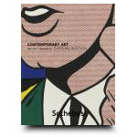

Auction Date
Session 1 | 11 Nov 08, 7:00 PM

Location
New York
Listino aggiudicazioni
a s e r v i c e b y www.ArsLife.com
Lot No. | Description | Estimate
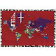 | 1 | Alighiero Boetti, 1940-1994 Mettere al Mondo  embroidered fabric  Read Condition Report | 600,000 – 800,00 USD  SOLD FOR 866.500
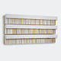 | 2 | - Rachel Whiteread, b. 1963 Untitled  plaster and steel  Read Condition Report | 400,000 – 600,000 USD  UNSOLD
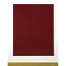 | 3 | - Gerhard Richter, b. 1932 Mirror Painting (Blood Red)  pigment on glass  Read Condition Report | 1,500,000 – 2,000,000 USD  SOLD FOR 1.314.500  Inizio modulo  Fine modulo
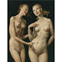 | 4 | - John Currin, b. 1962 Nice 'N Easy  oil on canvas  Read Condition Report | 3,500,000 – 4,500,000 USD  SOLD FOR 4.458.500
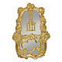 | 5 | - Jeff Koons, b. 1955 Wishing Well  gilded wood and mirror  Read Condition Report | 2,500,000 – 3,500,000 USD  Inizio modulo  SOLD FOR 2.154.500
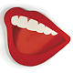 | 6 | Tom Wesselmann, 1931-2004 Mouth #3  oil on canvas  Read Condition Report | 1,500,000 – 2,000,000 USD  SOLD FOR 1.082.500
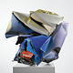 | 7 | - John Chamberlain, b. 1927 CA-D'ORO  painted steel  Read Condition Report | 1,800,000 – 2,200,000 USD  UNSOLD
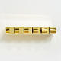 | 8 | - Donald Judd, 1928-1994 Untitled  brass  Read Condition Report | 900,000 – 1,200,000 USD  SOLD FOR 746.500
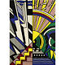 | 9 | Roy Lichtenstein, 1923-1997 Study for New York State Mural (Town and Country)  oil and Magna on canvas  Read Condition Report | 4,000,000 – 6,000,000 USD  SOLD FOR 3.890.500
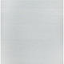 | 10 | Agnes Martin, 1912-2004 Untitled #5  acrylic and graphite on canvas  Read Condition Report | 2,000,000 – 3,000,000 USD  UNSOLD
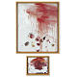 | 11 | - Cy Twombly, b. 1928 Untitled (A Painting in Two Parts) (Bassano in Teverina)  Top Panel: oil and wax crayon on canvas Bottom Panel: oil on canvas  Read Condition Report | 4,000,000 – 6,000,000 USD  SOLD FOR 4.785.500
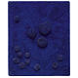 | 12 | Yves Klein, 1928-1962  Archisponge (RE11)  natural sponges, pebbles and dry blue pigment in synthetic resin on panel  Read Condition Report | Estimate Upon Request  SOLD FOR 21.362.500
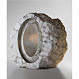 | 13 | - Anish Kapoor, b. 1954 Untitled  alabaster  Read Condition Report | 2,000,000 – 3,000,000 USD  UNSOLD
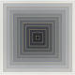 | 14 | Frank Stella, b. 1936  Untitled  acrylic and graphite on canvas  Read Condition Report | 2,000,000 – 3,000,000 USD  UNSOLD
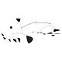 | 15 | Alexander Calder, 1898-1976 Deux Dates  painted metal and wire hanging mobile  Read Condition Report | 1,200,000 – 1,800,000 USD  SOLD FOR 2.490.500
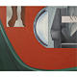 | 16 | James Rosenquist, b. 1933  In the Red  oil on canvas  Read Condition Report | 1,200,000 – 1,600,000 USD  UNSOLD
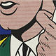 | 17 | - Roy Lichtenstein, 1923-1997  Half Face with Collar  oil and Magna on canvas  Read Condition Report | 15,000,000 – 20,000,000 USD  UNSOLD
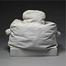 | 18 | Claes Oldenburg, b. 1929 Model (Ghost) Toaster (2/2)  painted canvas with kapok filling on a canvas-covered wood base  Read Condition Report | 400,000 – 600,000 USD  SOLD FOR 362.500
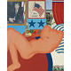 | 19 | Tom Wesselmann, 1931-2004 Great American Nude #21  oil and collage on board  Read Condition Report | 6,000,000 – 8,000,000 USD  SOLD FOR 4.114.500
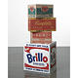 | 20 | Andy Warhol, 1928-1987 Set of Four Boxes: Brillo Soap Pads; Campbell's Tomato Juice; Del Monte Peach Halves; Heinz Tomato Ketchup  acrylic and silkscreen ink on wood in four parts  Read Condition Report | 2,500,000 – 3,500,000 USD  UNSOLD
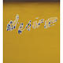 | 21 | Ed Ruscha, Desire  oil on canvas  Read Condition Report | 4,000,000 – 6,000,000 USD  SOLD FOR 2.434.500
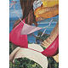 | 22 | - Jeff Koons, b. 1955 Cheeky  oil on canvas  Read Condition Report | 4,000,000 – 6,000,000 USD  SOLD FOR 4.002.500
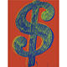 | 23 | - Andy Warhol, 1928-1987 Dollar Sign  acrylic and silkscreen ink on canvas  Read Condition Report | 2,500,000 – 3,500,000 USD  SOLD FOR 2.098.500
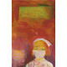 | 24 | - Richard Prince, b. 1949 Everglade Nurse  ink jet print and acrylic on canvas  Read Condition Report | 4,000,000 – 6,000,000 USD  SOLD FOR 3.442.500
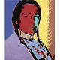 | 25 | Andy Warhol, 1928-1987  Portrait of an American Indian (Russell Means)  Acrylic and silkscreen ink on canvas  Read Condition Report | 1,500,000 – 2,000,000 USD  SOLD FOR 1.314.500
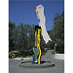 | 26 | Roy Lichtenstein, 1923-1997  Five Brushstrokes  painted and fabricated aluminum  Read Condition Report | 6,000,000 – 8,000,000 USD  UNSOLD
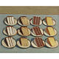 | 27 | - Wayne Thiebaud, b. 1920 Cut Cakes  oil on canvas  Read Condition Report | 2,000,000 – 3,000,000 USD  SOLD FOR 1.762.500
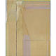 | 28 | Richard Diebenkorn, 1922-1993  Ocean Park No. 44  oil on canvas  Read Condition Report | 6,000,000 – 8,000,000 USD  SOLD FOR 5.234.500
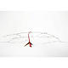 | 29 | - Alexander Calder, 1898-1976 Untitled  painted metal wire standing mobile  Read Condition Report | 1,000,000 – 1,500,000 USD  SOLD FOR 1.482.500
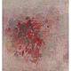 | 30 | - Philip Guston, 1913-1980 Beggar's Joys  oil on canvas  Read Condition Report | Estimate Upon Request  SOLD FOR 10.162.500
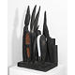 | 31 | - Louise Bourgeois, b. 1911 Forêt (Night Garden)  painted wood  Read Condition Report | 3,000,000 – 4,000,000 USD  SOLD FOR 3.330.500
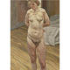 | 32 | - Lucian Freud, b. 1922  Naked Portrait Standing  Oil on canvas  Read Condition Report | 9,000,000 – 12,000,000 USD  UNSOLD
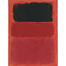 | 33 | Mark Rothko, 1903-1970 Untitled (Red/Black)  oil on paper mounted on canvas  Read Condition Report | 4,000,000 – 6,000,000 USD  SOLD FOR 4.170.500
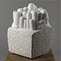 | 34 | - Louise Bourgeois, b. 1911 Clamart  marble and wood  Read Condition Report | 3,500,000 – 4,500,000 USD  SOLD FOR 3.442.500
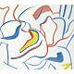 | 35 | - Willem de Kooning, 1904-1997  Untitled VI  oil on canvas  Read Condition Report | 5,000,000 – 7,000,000 USD  SOLD FOR 4.562.500
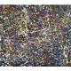 | 36 | Jean Paul Riopelle, 1923 - 2002 15 Chevaux Citroën  oil on canvas  Read Condition Report | 3,000,000 – 4,000,000 USD  UNSOLD
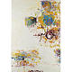 | 37 | Joan Mitchell, 1925-1992 Sunflower IV  oil on canvas  Read Condition Report | 2,000,000 – 3,000,000 USD  SOLD FOR 1.986.500
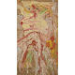 | 38 | Willem de Kooning, 1904-1997 Figure  oil on paper mounted on canvas  Read Condition Report | 2,500,000 – 3,500,000 USD  UNSOLD
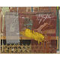 | 39 | - Robert Rauschenberg, Bantam  combine painting: oil, paper, printed reproductions, cardboard, fabric and pencil on canvas  Read Condition Report | 3,000,000 – 4,000,000 USD  SOLD FOR 2.602.500
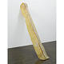 | 40 | Bruce Nauman, b. 1941 Untitled  fiberglass and polyester resin  Read Condition Report | 400,000 – 600,000 USD  SOLD FOR 338.500
 | 41 | Brice Marden, b. 1938 Souvenir de Grece 13  graphite, wax and collage on paper  Read Condition Report | 500,000 – 700,000 USD  SOLD FOR 362.500
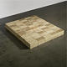 | 42 | Carl Andre, b. 1935 Equivalent V  sand-lime brick (1966)/firebrick (1969), 120-unit rectangular solid on floor; 2 high x 5 stretcher x 12 header  Read Condition Report | 1,200,000 – 1,600,000 USD  SOLD FOR 1.082.500
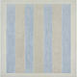 | 43 | Agnes Martin, 1912-2004 Untitled #7  acrylic, pencil and gesso on canvas  Read Condition Report | 2,500,000 – 3,500,000 USD  UNSOLD
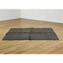 | 44 | - Richard Serra, b. 1939 Folded/Unfolded  lead  Read Condition Report | 600,000 – 800,000 USD  SOLD FOR 722.500
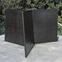 | 45 | Richard Serra, b. 1939 12-4-8  Cor-Ten Steel in 3 plates  Read Condition Report | 2,000,000 – 3,000,000 USD  SOLD FOR 1.650.500
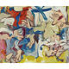 | 46 | Willem de Kooning, 1904-1997  Figures in Landscape no. 1  oil on paper laid down on canvas  Read Condition Report | 2,500,000 – 3,500,000 USD  SOLD FOR 1.818.500
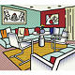 | 47 | Roy Lichtenstein, 1923-1997 Interior with Red Wall  oil and Magna on canvas  Read Condition Report | 8,000,000 – 10,000,000 USD  SOLD FOR 7.024.500
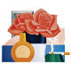 | 48 | Tom Wesselmann, 1931-2004  Still Life #58  oil on canvas  Read Condition Report | 3,000,000 – 4,000,000 USD  SOLD FOR 2.434.500
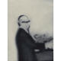 | 49 | Gerhard Richter, b. 1932 Portrait of Alfons Strawalski  oil on canvas  Read Condition Report | 2,000,000 – 3,000,000 USD  UNSOLD
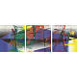 | 50 | Gerhard Richter, b. 1932 Abstraktes Bild (Blau)  oil on canvas on 3 panels  Read Condition Report | 4,500,000 – 6,500,000 USD  UNSOLD
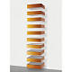 | 51 | Donald Judd, 1928-1994 Untitled (90-14 Bernstein)  anodized aluminum orange and light gray Plexiglas in 10 units  Read Condition Report | 2,000,000 – 3,000,000 USD  SOLD FOR 1.142.500
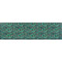 | 52 | - Andy Warhol, 1928-1987 Camouflage  synthetic polymer paint and silkscreen ink on canvas  Read Condition Report | 3,000,000 – 5,000,000 USD  SOLD FOR 2.658.500
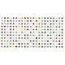 | 53 | Damien Hirst, b. 1965 Ethionamide  household gloss on canvas  Read Condition Report | 1,000,000 – 1,500,000 USD  UNSOLD
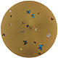 | 54 | Damien Hirst, b. 1965 Midas of Phrygia  butterflies and household gloss on canvas  Read Condition Report | 1,200,000 – 1,500,000 USD  SOLD FOR 1.082.500
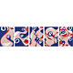 | 55 | - Takashi Murakami, B. 1962 Pity  acrylic on canvas in five parts  Read Condition Report | 1,000,000 – 1,500,000 USD  UNSOLD
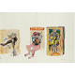 | 56 | Richard Prince, b. 1949 Untitled (with de Kooning)  acrylic, crayon, graphite and printed paper collage on paper  Read Condition Report | 300,000 – 400,000 USD  SOLD FOR 338.500
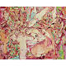 | 57 | - Cecily Brown, b. 1969 Kiss Me Stupid  oil on canvas  Read Condition Report | 800,000 – 1,000,000 USD  SOLD FOR 842.500
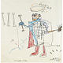 | 58 | - Jean-Michel Basquiat, 1960-1988 Ribs Ribs  oil paintstick on paper  Read Condition Report | 1,000,000 – 1,500,000 USD  SOLD FOR 626.500
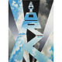 | 59 | Erik Bulatov, B. 1933 New York II  oil on canvas  Read Condition Report | 900,000 – 1,200,000 USD  ritirato
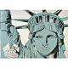 | 60 | - Andy Warhol, 1928-1987 Statue of Liberty  acrylic on canvas  Read Condition Report | 1,500,000 – 2,000,000 USD  SOLD FOR 1.202.500
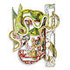 | 61 | Frank Stella, b. 1936 Jarama 2X  enamel on corrugated aluminum and metal wall relief  Read Condition Report | 700,000 – 900,000 USD  UNSOLD
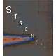 | 62 | - Edward Ruscha, b. 1937 Strength  oil on canvas  Read Condition Report | 1,200,000 – 1,600,000 USD  SOLD FOR 1.142.500
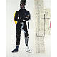 | 63 | Jean-Michel Basquiat, 1960-1988 MP  acrylic and xerox collage on canvas  Read Condition Report | 2,000,000 – 3,000,000 USD  UNSOLD
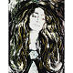 | 64 | Andy Warhol, 1928-1987 Eva Mudocci (after Munch)  acrylic and silkscreen on canvas  Read Condition Report | 1,500,000 – 2,000,000 USD  UNSOLD

