Contemporary Art Day Sale
SALE N08490
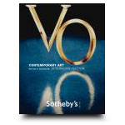

Auction Date
Session 1
12 Nov 08, ore 10:00 locali, 16.00 italiane

Location New York
Listino aggiudicazioni
a s e r v i c e b y www.ArsLife.com
lotti 101-305
TOTALE: 21,933,500 USD
Lot No. | Description | Estimate
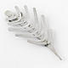 | 101 | Alexander Calder, 1898-1976 Untitled (Brooch)  silver  Read Condition Report | 30,000 – 40,000 USD  SOLD FOR  95,500 $
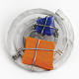 | 102 | Alexander Calder, 1898-1976 Untitled (Brooch)  silver, painted stone and wire  Read Condition Report | 70,000 – 90,000 USD  SOLD FOR  98,500 $
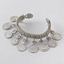 | 103 | Alexander Calder, 1898-1976 Untitled (Bracelet)  silver  Read Condition Report | 100,000 – 150,000 USD  SOLD FOR  110,500 $
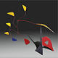 | 104 | Alexander Calder, 1898-1976  Six Leaves and Brass on Red and Black  painted sheet metal, brass and wire  Read Condition Report | 250,000 – 350,000 USD  SOLD FOR  422,500 $
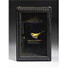 | 105 | Joseph Cornell, 1903-1972 Untitled (Yellow Bird Habitat)  illuminated box construction  Read Condition Report | 200,000 – 300,000 USD  SOLD FOR  170,500 $
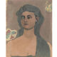 | 106 | John Graham, 1886-1961 La Strega Losca  oil on parchment  Read Condition Report | 300,000 – 400,000 USD  UNSOLD
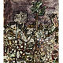 | 107 | Jean Dubuffet, 1901-1985 Paysage aux 3 arbres  oil and collage on canvas  Read Condition Report | 400,000 – 600,000 USD  SOLD FOR  350,500 $
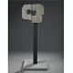 | 108 | Isamu Noguchi, 1904-1988 Variation on a Millstone #3  granite  Read Condition Report | 600,000 – 800,000 USD  UNSOLD
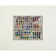 | 109 | Yaacov Agam, b. 1928 Tel Aviv  oil on wood relief  Read Condition Report | 40,000 – 60,000 USD  SOLD FOR  74,500 $
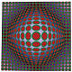 | 110 | Victor Vasarely, 1908-1997 Vega-Tek  tempera on canvas  Read Condition Report | 120,000 – 180,000 USD  SOLD FOR  122,500 $
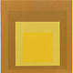 | 111 | Josef Albers, 1888-1976 Study for Homage to the Square: Open Land  oil on masonite  Read Condition Report | 250,000 – 350,000 USD  SOLD FOR  206,500 $
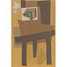 | 112 | Robert Motherwell, 1915-1991 The Easel I  paper collage and casein on particleboard  Read Condition Report | 120,000 – 180,000 USD  SOLD FOR  122,500 $
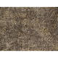 | 113 | - Jean Dubuffet, 1901-1985 Texturologie LXXIII (aux salissures)  oil on canvas  Read Condition Report | 180,000 – 250,000 USD  UNSOLD
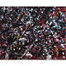 | 114 | - Jean-Paul Riopelle, 1923-2002  Sans Titre  oil on canvas  Read Condition Report | 500,000 – 700,000 USD  SOLD FOR  386,500 $
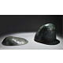 | 115 | Isamu Noguchi, 1904-1988 Seen and Unseen  bronze, in 2 parts  Read Condition Report | 150,000 – 200,000 USD  UNSOLD
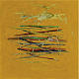 | 116 | Robert Irwin, b. 1928 Ocean Park  oil on canvas  Read Condition Report | 600,000 – 800,000 USD  UNSOLD
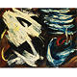 | 117 | - Gérard Schneider, 1896-1986 10-D  oil on canvas  Read Condition Report | 80,000 – 120,000 USD  UNSOLD
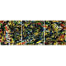 | 118 | Norman Bluhm, 1921-1999 F State  oil on canvas, in 3 parts  Read Condition Report | 30,000 – 40,000 USD  SOLD FOR  40,000 $
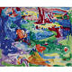 | 119 | Hans Hofmann, 1880-1966 Landscape  casein on panel  Read Condition Report | 80,000 – 120,000 USD  UNSOLD
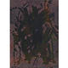 | 120 | Yayoi Kusama, b. 1929 Sky No. 1  watercolor and gouache on paper  Read Condition Report | 25,000 – 35,000 USD  SOLD FOR  27,500 $
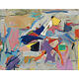 | 121 | Esteban Vicente, 1903-2001 Untitled  oil on canvas  Read Condition Report | 40,000 – 60,000 USD  SOLD FOR  86,500
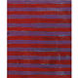 | 122 | Frank Stella, b. 1936 Untitled  enamel and oil on canvasboard mounted on foamcore  Read Condition Report | 300,000 – 400,000 USD  UNSOLD
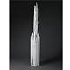 | 123 | Louise Nevelson, 1899-1988 Dawn's Wedding Feast Totem II  wood, painted white, in 2 parts  Read Condition Report | 200,000 – 300,000 USD  UNSOLD
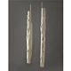 | 124 | Louise Nevelson, 1899-1988 Dawn's Wedding Columns (A and B)  wood, painted white, in 2 parts  Read Condition Report | 70,000 – 90,000 USD  SOLD FOR  74,500 $
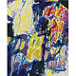 | 125 | Sam Francis, 1923 - 1994 Sioux Falls, Idaho  oil on canvas  Read Condition Report | 250,000 – 350,000 USD  UNSOLD
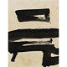 | 126 | Franz Kline, 1910-1962 Untitled  ink on paper  Read Condition Report | 200,000 – 250,000 USD  UNSOLD
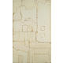 | 127 | Conrad Marca-Relli, b. 1913 Room B-3 l-7-62  painted tin collage mounted on panel  Read Condition Report | 70,000 – 90,000 USD  SOLD FOR  108,100 $
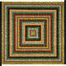 | 128 | Alfred Jensen, 1903-1981 Reciprocal Relation, Per 3, Per 4  oil on canvas  Read Condition Report | 50,000 – 70,000 USD  SOLD FOR  74,500 $
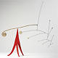 | 129 | Alexander Calder, 1898-1976 Untitled  painted metal and brass standing mobile  Read Condition Report | 400,000 – 600,000 USD  SOLD FOR  710,500 $
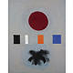 | 130 | Adolph Gottlieb, 1903-1974 Scale  oil on canvas  Read Condition Report | 400,000 – 600,000 USD  SOLD FOR  350,500 $
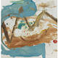 | 131 | Helen Frankenthaler, b. 1928 Soul of the Albino  oil on canvas primed with gesso  Read Condition Report | 250,000 – 350,000 USD  SOLD FOR  458,500 $
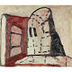 | 132 | Philip Guston, 1913-1980 Melancholy  oil on masonite  Read Condition Report | 250,000 – 350,000 USD  SOLD FOR  326,500 $
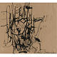 | 133 | Philip Guston, 1913-1980 Untitled  ink on paper  Read Condition Report | 80,000 – 120,000 USD  UNSOLD
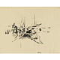 | 134 | Philip Guston, 1913-1980 Untitled  ink on paper  Read Condition Report | 60,000 – 80,000 USD  SOLD FOR  74,500 $
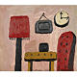 | 135 | Philip Guston, 1913-1980 Interior  oil on board  Read Condition Report | 150,000 – 200,000 USD  SOLD FOR  218,500 $
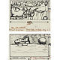 | 136 | Philip Guston, 1913-1980 Painter in Bed and Shoe (Two Works)  ink on card  Read Condition Report | 20,000 – 30,000 USD  SOLD FOR  110,500 $
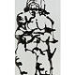 | 137 | David Smith, 1906-1965 Untitled (Nude)  enamel on canvas  Read Condition Report | 200,000 – 300,000 USD  SOLD FOR  116,500 $
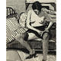 | 138 | Richard Diebenkorn, 1922-1993 Untitled (Seated Woman, Dressing, #35)  Conté crayon and ink wash on paper  Read Condition Report | 250,000 – 350,000 USD  UNSOLD
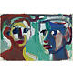 | 139 | David Park, 1911-1960 Two Heads II  gouache on paper  Read Condition Report | 100,000 – 150,000 USD  SOLD FOR  182,500 $
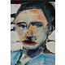 | 140 | Richard Diebenkorn, 1922-1993 Untitled  oil on canvas  Read Condition Report | 250,000 – 350,000 USD  UNSOLD
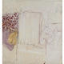 | 141 | Paul Wonner, b. 1920 Still Life  oil on canvas  Read Condition Report | 80,000 – 120,000 USD  SOLD FOR  60,000 $
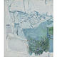 | 142 | Paul Wonner, b. 1920 Seascape No. 2  oil on canvas  Read Condition Report | 80,000 – 120,000 USD  UNSOLD
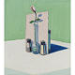 | 143 | Wayne Thiebaud, b. 1920 Flower in Vase  oil on canvas  Read Condition Report | 700,000 – 900,000 USD  UNSOLD
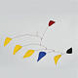 | 144 | Alexander Calder, 1898-1976 Plûtot Jaune  painted sheet metal and wire  Read Condition Report | 400,000 – 600,000 USD  SOLD FOR  470,500 $
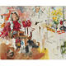 | 145 | Larry Rivers, 1923-2002 Untitled  oil on canvas  Read Condition Report | 150,000 – 200,000 USD  SOLD FOR  230,500 $
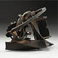 | 146 | Mark di Suvero, b. 1933 Untitled  welded steel  Read Condition Report | 60,000 – 80,000 USD  SOLD FOR  230,500 $
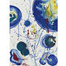 | 147 | Sam Francis, 1923 - 1994 Untitled (Blue Balls)  gouache on paper  Read Condition Report | 40,000 – 60,000 USD  SOLD FOR  47,500 $
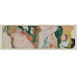 | 148 | Willem de Kooning, 1904-1997 Untitled  oil on paper mounted on paper  Read Condition Report | 80,000 – 120,000 USD  SOLD FOR  146,500 $
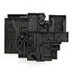 | 149 | Louise Nevelson, 1899-1988 Night Zag Wall  wood, painted black, in 14 parts  Read Condition Report | 300,000 – 400,000 USD  SOLD FOR  350,500 $
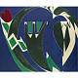 | 150 | Lee Krasner, 1908-1984 Majuscule  oil on canvas  Read Condition Report | 400,000 – 600,000 USD  UNSOLD
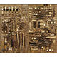 | 151 | Arnaldo Pomodoro, b. 1926  Bassorilievo  bronze  Read Condition Report | 250,000 – 350,000 USD  SOLD FOR  254,500 $
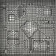 | 152 | Victor Vasarely, 1908-1997 Ipam  acrylic on canvas  Read Condition Report | 150,000 – 200,000 USD  UNSOLD
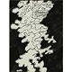 | 153 | Jean Dubuffet, 1901-1985 Personnage Fond Noir D 82  Chinese ink on paper  Read Condition Report | 30,000 – 40,000 USD  SOLD FOR  31,250 $
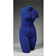 | 154 | Yves Klein, 1928-1962 Vénus Bleue  pigment and synthetic resin on plaster cast  Read Condition Report | 60,000 – 80,000 USD  SOLD FOR  74,500 $
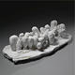 | 155 | Louise Bourgeois, b. 1911  Untitled (Fingers)  plaster  Read Condition Report | 150,000 – 200,000 USD  SOLD FOR  134,500 $
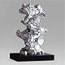 | 156 | Jean Dubuffet, 1901-1985 L'expansion  epoxy paint on polyurethane  Read Condition Report | 800,000 – 1,200,000 USD  SOLD FOR  770,500 $
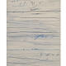 | 157 | - Cy Twombly, b. 1928  Untitled  oil, pencil, oilstick and paper collage on paper mounted on card  Read Condition Report | 300,000 – 400,000 USD  SOLD FOR  314,500 $
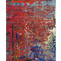 | 158 | Gerhard Richter, b. 1932 Abstraktes Bild (630-1)  oil on canvas  Read Condition Report | 1,800,000 – 2,500,000 USD  SOLD FOR  1,986,500 $
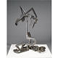 | 159 | Mark di Suvero, b. 1933 Queen's Knight  steel, in 2 parts  Read Condition Report | 80,000 – 120,000 USD  SOLD FOR  98,500 $
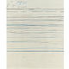 | 160 | Cy Twombly, b. 1928 Untitled  gouache and wax crayon on paperboard, in 2 parts  Read Condition Report | 550,000 – 750,000 USD  UNSOLD
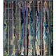 | 161 | Gerhard Richter, b. 1932  Abstraktes Bild (776-1)  oil on canvas  Read Condition Report | 600,000 – 800,000 USD  UNSOLD
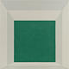 | 162 | Josef Albers, 1888-1976 Homage to the Square: Stucco Framed  oil on masonite  Read Condition Report | 400,000 – 600,000 USD  UNSOLD
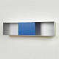 | 163 | Donald Judd, 1928-1994 Untitled  clear and blue anodized aluminum  Read Condition Report | 300,000 – 400,000 USD  SOLD FOR  302,500 $
 | 164 | Dan Flavin, 1933-1996 Untitled (To Rainer) 2  cool white and warm white fluorescent light  Read Condition Report | 300,000 – 400,000 USD SOLD FOR  242,500 $
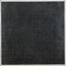 | 165 | - Brice Marden, b. 1938 Untitled  charcoal and beeswax on paper  Read Condition Report | 400,000 – 600,000 USD  UNSOLD
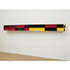 | 166 | Donald Judd, 1928-1994 Untitled (84-25 Lehni)  painted aluminum  Read Condition Report | 400,000 – 600,000 USD  SOLD FOR  482,500 $
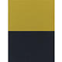 | 167 | - Brice Marden, b. 1938 Air & Water  oil on canvas  Read Condition Report | 500,000 – 700,000 USD  UNSOLD
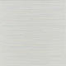 | 168 | Sol LeWitt, 1928 - 2007  Alternate Parallel Straight Black, Yellow, Red and Blue Lines of Random Length, Not Touching the Sides of the Page  ink on paper  Read Condition Report | 30,000 – 40,000 USD  SOLD FOR  32,500 $
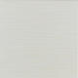 | 169 | Sol LeWitt, 1928 - 2007  Alternate Yellow Ink and Pencil Straight Parallel Lines of Random Length, Not Touching The Sides  ink and pencil on paper  Read Condition Report | 30,000 – 40,000 USD  UNSOLD
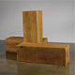 | 170 | Carl Andre, b. 1935 The Way East West (Uncarved Blocks, 1975.57)  3 blocks of western red cedar, 2 horizontal pointing east and west respectively, adjacent to base of 1 vertical  Read Condition Report | 300,000 – 400,000 USD  UNSOLD
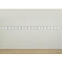 | 171 | Robert Ryman, b. 1930 18 Panels (Study for Brussels)  acrylic polymer on black and dark blue vinyl panels, in 18 parts  Read Condition Report | 1,200,000 – 1,800,000 USD  UNSOLD
 | 172 | Robert Mangold, b. 1937 A 90° Arc and a Circle within a Square (A Quarter Circle and a Circle Within a Square)  acrylic and graphite on canvas  Read Condition Report | 200,000 – 300,000 USD  UNSOLD
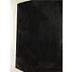 | 173 | Richard Serra, b. 1939 St. Louis II  oilstick on paper  Read Condition Report | 250,000 – 350,000 USD  UNSOLD
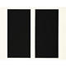 | 174 | John McLaughlin, 1898-1976 #33 - 1964  oil on canvas  Read Condition Report | 40,000 – 60,000 USD  SOLD FOR  50,000 $
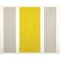 | 175 | John McLaughlin, 1898-1976 #13-1964  oil on canvas  Read Condition Report | 40,000 – 60,000 USD  SOLD FOR  37,500 $
 | 176 | Robert Mangold, b. 1937 Green / 2 Orange X Painting  acrylic and black pencil on canvas  Read Condition Report | 150,000 – 200,000 USD  SOLD FOR  206,500 $
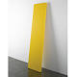 | 177 | John McCracken, b. 1934 Untitled  polyester resin and fiberglass on plywood  Read Condition Report | 120,000 – 180,000 USD  SOLD FOR  188,500 $
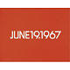 | 178 | On Kawara, b. 1933 June 19, 1967  liquitex on canvas  Read Condition Report | 250,000 – 350,000 USD  SOLD FOR  302,500 $
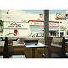 | 179 | Ralph Goings, b. 1928 Kentucky Fried Chicken  oil on canvas  Read Condition Report | 400,000 – 600,000 USD  UNSOLD
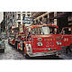 | 180 | Ron Kleemann, b. 1937 Perfect Vision  oil on canvas  Read Condition Report | 150,000 – 200,000 USD  UNSOLD
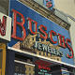 | 181 | Robert Cottingham, b. 1935 Buschs  oil on canvas  Read Condition Report | 150,000 – 250,000 USD  UNSOLD
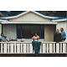 | 182 | Robert Bechtle, b. 1932 Stinson Beach Deck  oil on canvas  Read Condition Report | 200,000 – 400,000 USD  UNSOLD
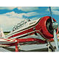 | 183 | Tom Blackwell, B. 1938 Shatzi  oil on masonite  Read Condition Report | 20,000 – 30,000 USD  UNSOLD
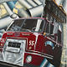 | 184 | Ron Kleemann, b. 1937 International Harvest...er  acrylic on canvas  Read Condition Report | 80,000 – 100,000 USD  UNSOLD
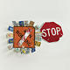 | 185 | Robert Rauschenberg, 1925-2008 Traffic Flower Glut  assemblage with printed metal license plates and traffic signs, in 2 parts  Read Condition Report | 300,000 – 400,000 USD  SOLD FOR  362,500 $
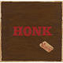 | 186 | - Edward Ruscha, b. 1937 Honk (Cracker Jack)  oil, black ink and pencil on paper mounted on board  Read Condition Report | 1,000,000 – 1,500,000 USD  SOLD FOR  746,500 $
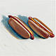 | 187 | Wayne Thiebaud, b. 1920 Two Hot Dogs  oil on canvas  Read Condition Report | 500,000 – 700,000 USD  UNSOLD
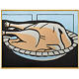 | 188 | Richard Pettibone, b. 1938 Roy Lichtenstein, Turkey, 1961  acrylic and silkscreen inks on canvas in artist's wood frame  Read Condition Report | 18,000 – 25,000 USD  UNSOLD
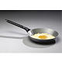 | 189 | Claes Oldenburg, b. 1929 Fried Egg in Pan  painted plaster and aluminum frying pan  Read Condition Report | 40,000 – 60,000 USD  SOLD FOR  52,500 $
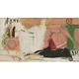 | 190 | Larry Rivers, 1923-2002  French Money  oil on canvas  Read Condition Report | 300,000 – 400,000 USD  SOLD FOR  290,500 $
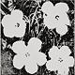 | 191 | Andy Warhol, 1928-1987 Flowers  acrylic and silkscreen inks on canvas  Read Condition Report | 80,000 – 100,000 USD  UNSOLD
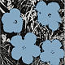 | 192 | Andy Warhol, 1928-1987 Flowers  acrylic and silkscreen inks on canvas  Read Condition Report | 100,000 – 150,000 USD  UNSOLD
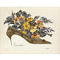 | 193 | Andy Warhol, 1928-1987  Untitled (Gold Shoe with Flower Bouquet)  gold leaf, silver trim, collage, watercolor and ink on Strathmore paper  Read Condition Report | 250,000 – 350,000 USD  SOLD FOR  374,500 $
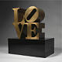 | 194 | Robert Indiana, b.1928 Love  bronze  Read Condition Report | 100,000 – 150,000 USD  SOLD FOR  212,500 $
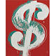 | 195 | Andy Warhol, 1928-1987 Dollar Sign  acrylic and silkscreen inks on canvas  Read Condition Report | 300,000 – 400,000 USD  UNSOLD
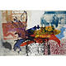 | 196 | Robert Rauschenberg, b. 1925 Gospel Yodel  acrylic on canvas  Read Condition Report | 800,000 – 1,200,000 USD  UNSOLD
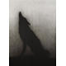 | 197 | Edward Ruscha, b. 1937  Yip Yip  acrylic on canvas  Read Condition Report | 1,500,000 – 2,000,000 USD  SOLD FOR  1,070,500 $
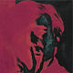 | 198 | - Andy Warhol, 1928-1987 Self-Portrait  acrylic and silkscreen ink on canvas  Read Condition Report | 800,000 – 1,200,000 USD  SOLD FOR  518,500 $
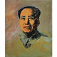 | 199 | Andy Warhol, 1928-1987 Mao  acrylic and silkscreen ink on canvas  Read Condition Report | 500,000 – 700,000 USD  UNSOLD
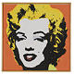 | 200 | Richard Pettibone, b. 1938 Andy Warhol, Marilyn, 1964  acrylic and silkscreen ink on canvas in artist's wood frame  Read Condition Report | 60,000 – 80,000 USD  SOLD FOR  80,500 $

Lot No. | Description | Estimate
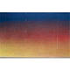 | 201 | Edward Ruscha, b. 1937  Abstract Painting  acrylic on canvas  Read Condition Report | 500,000 – 700,000 USD  UNSOLD
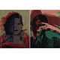 | 202 | - Andy Warhol, 1928-1987 Ladies and Gentleman (Two Works)  acrylic and silkscreen ink on canvas, in 2 parts  Read Condition Report | 200,000 – 300,000 USD  UNSOLD
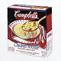 | 204 | Andy Warhol, 1928-1987 Campbell's Chicken Noodle Soup Box  acrylic and silkscreen ink on canvas  Read Condition Report | 300,000 – 400,000 USD  SOLD FOR  218,500 $
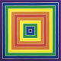 | 205 | Frank Stella, b. 1936 Untitled  acrylic on canvas  Read Condition Report | 1,200,000 – 1,800,000 USD  UNSOLD
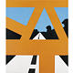 | 206 | Allan D'Arcangelo, 1930 - 1998 Overpass  acrylic on canvas  Read Condition Report | 120,000 – 180,000 USD  UNSOLD
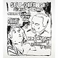 | 207 | - Andy Warhol, 1928-1987 Self Defense  synthetic polymer paint and silkscreen ink on canvas  Read Condition Report | 700,000 – 900,000 USD  UNSOLD
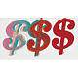 | 208 | Andy Warhol, 1928-1987 Three Dollar Signs  acrylic and silkscreen inks on canvas  Read Condition Report | 400,000 – 600,000 USD  UNSOLD
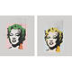 | 209 | Richard Pettibone, b. 1938 Andy Warhol, Marilyn, 1978 (Two Works)  acrylic and silkscreen ink on canvas, in 2 parts  Read Condition Report | 40,000 – 60,000 USD  UNSOLD
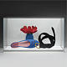 | 210 | Tom Wesselmann, 1931-2004 Maquette for Belt Still Life (Sculpture) (Version #2)  liquitex on ragboard  Read Condition Report | 30,000 – 40,000 USD  SOLD FOR  50,000 $
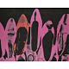 | 211 | Andy Warhol, 1928-1987 Diamond Dust Shoes  acrylic and silkscreen ink with diamond dust on canvas  Read Condition Report | 1,500,000 – 2,000,000 USD  SOLD FOR  1,258,500
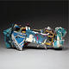 | 212 | John Chamberlain, b. 1927 Tonk #27-83  painted steel  Read Condition Report | 100,000 – 150,000 USD  UNSOLD
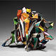 | 213 | John Chamberlain, b. 1927 Fisftful of Fun  painted and chromium plated steel  Read Condition Report | 150,000 – 200,000 USD  SOLD FOR  182,500 $
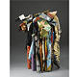 | 214 | John Chamberlain, b. 1927 Bent Tynes  painted steel  Read Condition Report | 700,000 – 900,000 USD  UNSOLD
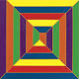 | 215 | Frank Stella, b. 1936 Maze  fluorescent acrylic on canvas  Read Condition Report | 600,000 – 800,000 USD  UNSOLD
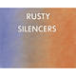 | 216 | - Edward Ruscha, b. 1937 Rusty Silencers  pastel and graphite on Grumbacher paper  Read Condition Report | 250,000 – 350,000 USD  UNSOLD
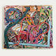 | 217 | Frank Stella, b. 1936 Diepholz  mixed media on etched magnesium on aluminum  Read Condition Report | 250,000 – 350,000 USD  UNSOLD
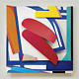 | 218 | Tom Wesselmann, 1931-2004 Summer Cardinal  oil on cut-out aluminum  Read Condition Report | 500,000 – 700,000 USD  SOLD FOR  338,500 $
 | 219 | Robert Indiana, b.1928 Love  painted aluminum  Read Condition Report | 1,200,000 – 1,800,000 USD  UNSOLD
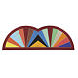 | 220 | Frank Stella, b. 1936 Khurasan Gate III  acrylic and pencil on shaped canvas  Read Condition Report | 700,000 – 900,000 USD  UNSOLD
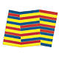 | 221 | Frank Stella, b. 1936 Bampur  fluorescent alkyd on canvas  Read Condition Report | 500,000 – 700,000 USD  UNSOLD
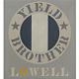 | 222 | Robert Indiana, b.1928 Yield Brother Lowell  acrylic on canvas  Read Condition Report | 200,000 – 300,000 USD  UNSOLD
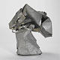 | 223 | John Chamberlain, b. 1927 Untitled  galvanized steel  Read Condition Report | 650,000 – 850,000 USD  UNSOLD
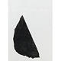 | 224 | Giuseppe Penone, b. 1947 Untitled  charcoal on paper collage, pencil and oil on paper  Read Condition Report | 10,000 – 15,000 USD  SOLD FOR  10,625 $
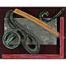 | 225 | Frank Stella, b. 1936 Bonin Night Heron  lacquer and oil on aluminum  Read Condition Report | 150,000 – 200,000 USD  UNSOLD
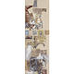 | 226 | Robert Rauschenberg, 1925-2008 Untitled  solvent transfer, gouache, pencil and collage on paper  Read Condition Report | 300,000 – 400,000 USD  UNSOLD
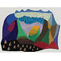 | 227 | David Hockney, b. 1937 Sinked  gouache on paper  Read Condition Report | 120,000 – 180,000 USD  UNSOLD
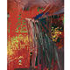 | 228 | Gerhard Richter, b. 1932 Abstraktes Bild (592-3)  oil on canvas  Read Condition Report | 800,000 – 1,200,000 USD  UNSOLD
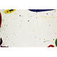 | 229 | Sam Francis, 1923 - 1994 Untitled (SF63-044)  acrylic on paper  Read Condition Report | 35,000 – 45,000 USD  SOLD FOR  37,500 $
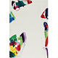 | 230 | Sam Francis, 1923 - 1994 Untitled (SF70-006)  acrylic on paper  Read Condition Report | 50,000 – 70,000 USD  UNSOLD
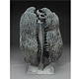 | 231 | Harry Bertoia, 1915-1978 Untitled  bronze  Read Condition Report | 80,000 – 120,000 USD  SOLD FOR  92,500 $
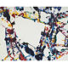 | 232 | Sam Francis, 1923 - 1994  Green  acrylic and oil on canvas  Read Condition Report | 400,000 – 600,000 USD  UNSOLD
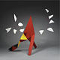 | 233 | Alexander Calder, 1898-1976 Five White Against Five White  painted sheet metal and rod  Read Condition Report | 700,000 – 900,000 USD  UNSOLD
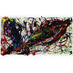 | 234 | Sam Francis, 1923-1994 Untitled (SF90-169)  acrylic on paper  Read Condition Report | 150,000 – 200,000 USD  UNSOLD
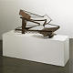 | 235 | Anthony Caro, b. 1924 Table Piece CCCCVII  steel rusted and varnished  Read Condition Report | 55,000 – 65,000 USD  SOLD FOR  50,000 $
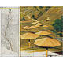 | 236 | Christo, 1935 The Umbrellas (Project for Japan and Western USA)  pencil, fabric, pastel, wax crayon, charcoal, topographic map and enamel paint on board; collage in two parts  Read Condition Report | 80,000 – 120,000 USD  SOLD FOR  104,500 $
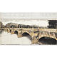 | 237 | Christo, b. 1935 The Pont Neuf Wrapped (Project for Paris)  pencil, charcoal, pastel, wax crayon and technical data; drawing in two parts  Read Condition Report | 200,000 – 300,000 USD  SOLD FOR  212,500 $
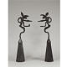 | 238 | Barry Flanagan, b. 1941 Mirror Nijinsky  bronze with brown patina  Read Condition Report | 500,000 – 700,000 USD  UNSOLD
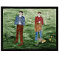 | 239 | Neil Jenney, b. 1945  Schmuck and Schlemiel  acrylic and graphite on canvas in artist's frame  Read Condition Report | 250,000 – 350,000 USD  SOLD FOR  182,500 $
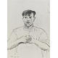 | 240 | David Hockney, b. 1937  Pierre St. Jean  charcoal on paper  Read Condition Report | 25,000 – 35,000 USD  UNSOLD
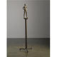 | 241 | Robert Graham, b.1938 Christine  bronze with light brown patina  Read Condition Report | 30,000 – 40,000 USD  SOLD FOR  37,500 $
 | 242 | Alex Katz, b. 1927 Double Ada  oil on canvas  Read Condition Report | 200,000 – 300,000 USD  UNSOLD
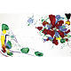 | 243 | Sam Francis, 1923 - 1994 My Hand in Yours  acrylic on canvas  Read Condition Report | 350,000 – 500,000 USD  SOLD FOR  302,500 $
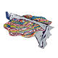 | 244 | Frank Stella, b. 1936 Stubb's Supper (5-L3X)  mixed media on cast aluminum  Read Condition Report | 300,000 – 400,000 USD  UNSOLD
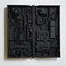 | 245 | Louise Nevelson, 1899-1988 Untitled  wood, painted black  Read Condition Report | 150,000 – 200,000 USD  UNSOLD
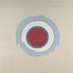 | 246 | Kenneth Noland, b. 1924 Round  acrylic on canvas  Read Condition Report | 1,000,000 – 1,200,000 USD  UNSOLD
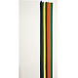 | 247 | Morris Louis, 1912-1962 Number 32  Magna on canvas  Read Condition Report | 600,000 – 800,000 USD  SOLD FOR  572,500 $
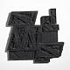 | 248 | Louise Nevelson, 1899-1988 Moon Zag XI  wood, painted black  Read Condition Report | 100,000 – 150,000 USD  UNSOLD
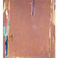 | 249 | Helen Frankenthaler, b. 1928 Cortez Junction  acrylic on canvas  Read Condition Report | 350,000 – 450,000 USD  SOLD FOR  278,500 $
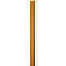 | 250 | Morris Louis, 1912-1962 Number 49  magna on canvas  Read Condition Report | 300,000 – 400,000 USD  SOLD FOR  242,500 $
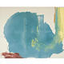 | 251 | Helen Frankenthaler, b. 1928 Where Necessary  acrylic on canvas  Read Condition Report | 300,000 – 500,000 USD  UNSOLD
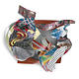 | 252 | Frank Stella, b. 1936 The Musket  assemblage and mixed media  Read Condition Report | 250,000 – 350,000 USD  UNSOLD
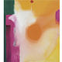 | 253 | Helen Frankenthaler, b. 1928  Bullseye  acrylic on canvas  Read Condition Report | 250,000 – 350,000 USD  UNSOLD
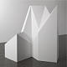 | 254 | Sol LeWitt, 1928 - 2007  Strutture (Complex Form #9)  wood, painted white  Read Condition Report | 150,000 – 200,000 USD  UNSOLD
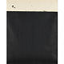 | 255 | Richard Serra, b. 1939  Bilbao Jungle  oilstick on paper  Read Condition Report | 150,000 – 200,000 USD  SOLD FOR  158,500
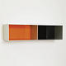 | 256 | Donald Judd, 1928-1994 Untitled  aluminum with colored Plexiglas  Read Condition Report | 250,000 – 350,000 USD  SOLD FOR  242,500 $
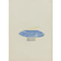 | 257 | - Richard Tuttle, b. 1941  Titre 2  graphite, watercolor and collage on paper  Read Condition Report | 20,000 – 30,000 USD  UNSOLD
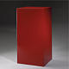 | 258 | John McCracken, b. 1934 Mineral  polyester resin and fiberglass on plywood  Read Condition Report | 25,000 – 35,000 USD  SOLD FOR  50,000 $
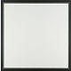 | 259 | Jo Baer, b. 1929 Untitled  oil on canvas  Read Condition Report | 40,000 – 60,000 USD  SOLD FOR  46,875 $
 | 260 | Sol LeWitt, 1928 - 2007 Lines in Four Directions  wood, painted white  Read Condition Report | 60,000 – 80,000 USD  UNSOLD
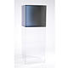 | 261 | Larry Bell, b. 1939 Untitled  Plexiglas, in 2 parts  Read Condition Report | 40,000 – 60,000 USD  UNSOLD
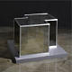 | 262 | Dan Graham, b. 1942 Two-Way Mirror Joined Cubes  mirror, glass and aluminum  Read Condition Report | 30,000 – 40,000 USD  SOLD FOR  25,000 $
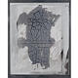 | 263 | Robert Rauschenberg, 1925-2008 From the Bleacher Series: Cracked Surface and Rivets I  manipulated black-and-white Polaroid photograph mounted on aluminum  Read Condition Report | 50,000 – 70,000 USD  UNSOLD
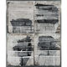 | 264 | Robert Rauschenberg, 1925-2008 From The Bleacher Series: Chinese Steps II  manipulated black-and-white Polaroid photographs mounted on aluminum  Read Condition Report | 120,000 – 180,000 USD  UNSOLD
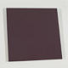 | 265 | Ellsworth Kelly, b. 1923 Dark Red-Violet Panel  painted aluminum  Read Condition Report | 100,000 – 150,000 USD  SOLD FOR  104,500 $
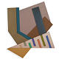 | 266 | Frank Stella, b. 1936 Kozangrodek II  acrylic, felt, canvas, cardboard and pressboard on wood, in 2 parts  Read Condition Report | 100,000 – 150,000 USD  SOLD FOR  86,500 $
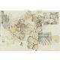 | 267 | Robert Rauschenberg, b. 1925  Battery  solvent transfer, graphite and watercolor on paper  Read Condition Report | 150,000 – 200,000 USD  UNSOLD
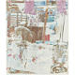 | 268 | Robert Rauschenberg, b. 1925 Kitchen Camoflauge (Anagrams)  vegetable dye transfer on paper  Read Condition Report | 100,000 – 150,000 USD  SOLD FOR  40,625 $
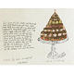 | 269 | - Andy Warhol, 1928-1987 Torte a La Dobosch  gold leaf, ink and ink wash on paper  Read Condition Report | 20,000 – 30,000 USD  UNSOLD
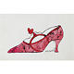 | 270 | - Andy Warhol, 1928-1987 High Heel Shoe  aniline dye on Strathmore paper  Read Condition Report | 25,000 – 35,000 USD  SOLD FOR  50,000 $
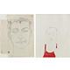 | 271 | - Andy Warhol, 1928-1987 Male Head (Early) and Dusty Cook (Two Works)  i: graphite on taped sheets of bond paper  ii: ink and Dr. Martin's aniline dye on Strathmore paper  Read Condition Report | 25,000 – 30,000 USD  UNSOLD
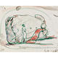 | 272 | - Claes Oldenburg, b. 1929 Study for a Huge Stuffed Shirt with Tie, Woman Standing for Scale  gouache and crayon on paper  Read Condition Report | 18,000 – 25,000 USD  SOLD FOR  16,250 $
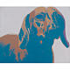 | 273 | Andy Warhol, 1928-1987 Dog (Dachshund)  acrylic and silkscreen ink on canvas  Read Condition Report | 150,000 – 200,000 USD  UNSOLD
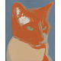 | 274 | Andy Warhol, 1928-1987  Broadway  acrylic and silkscreen inks on canvas  Read Condition Report | 200,000 – 300,000 USD  UNSOLD
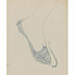 | 275 | - Andy Warhol, 1928-1987 Foot  ballpoint pen on paper  Read Condition Report | 15,000 – 20,000 USD  UNSOLD
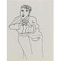 | 276 | - Andy Warhol, 1928-1987 Unidentified Male Portrait  ink on paper  Read Condition Report | 12,000 – 18,000 USD  UNSOLD
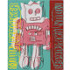 | 277 | Andy Warhol, 1928-1987 Moon Explorer  acrylic and silkscreen ink on canvas  Read Condition Report | 100,000 – 150,000 USD  SOLD FOR  98,500 $
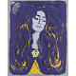 | 278 | Andy Warhol, 1928-1987 Eva Mudocci  unique silkscreen ink on paper  Read Condition Report | 150,000 – 200,000 USD  UNSOLD
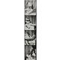 | 279 | Andy Warhol, 1928-1987 Untitled (Self-Portrait)  black and white photograph strip  Read Condition Report | 40,000 – 60,000 USD  UNSOLD
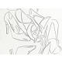 | 280 | Andy Warhol, 1928-1987 Shoes  graphite on HMP paper  Read Condition Report | 35,000 – 45,000 USD  UNSOLD
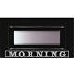 | 281 | Neil Jenney, b. 1945  Morning  oil on masonite in artist's painted wood frame  Read Condition Report | 40,000 – 60,000 USD  SOLD FOR  13,750 $
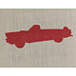 | 282 | Edward Ruscha, b. 1937 T-Bird  acrylic on raw linen  Read Condition Report | 40,000 – 60,000 USD  UNSOLD
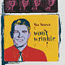 | 283 | Andy Warhol, 1928-1987 Van Heusen (Reagan)  acrylic and silkscreen ink on canvas  Read Condition Report | 120,000 – 180,000 USD  SOLD FOR  146,500 $
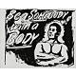 | 284 | Andy Warhol, 1928-1987 Be Somebody with a Body  acrylic and silkscreen ink on canvas  Read Condition Report | 80,000 – 120,000 USD  UNSOLD
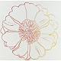 | 285 | Andy Warhol, 1928-1987 Daisy  silkscreen on paperboard  Read Condition Report | 60,000 – 80,000 USD  UNSOLD
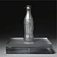 | 286 | Andy Warhol, 1928-1987 You're In  spray paint on Coca-Cola bottle  Read Condition Report | 40,000 – 60,000 USD  SOLD FOR  62,500 $
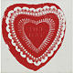 | 287 | Andy Warhol, 1928-1987 Valentine  acrylic and silkscreen ink on canvas  Read Condition Report | 70,000 – 90,000 USD  SOLD FOR  86,500 $
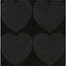 | 288 | Andy Warhol, 1928-1987 Diamond Dust Hearts  acrylic, silkscreen ink and diamond dust on canvas  Read Condition Report | 80,000 – 120,000 USD  SOLD FOR  80,500 $
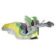 | 289 | Frank Stella, b. 1936 Cistern and Buckets  mixed media on aluminum  Read Condition Report | 300,000 – 400,000 USD  UNSOLD
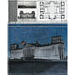 | 290 | Christo, 1935 Wrapped Reichstag (Project for Berlin)  pencil, pastel, charcoal, wax crayon, fabric, thread, two photographs by Wolfgang Volz, fabric sample and architectural floor plan; collage in two parts  Read Condition Report | 80,000 – 120,000 USD  SOLD FOR  80,500 $
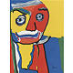 | 291 | Karel Appel, 1921-2006 Head  acrylic on canvas  Read Condition Report | 60,000 – 80,000 USD  UNSOLD
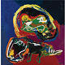 | 292 | Karel Appel, 1921-2006  Man with Dog  oil on canvas  Read Condition Report | 80,000 – 120,000 USD  SOLD FOR  98,500 $
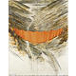 | 293 | Christo, 1935 Valley Curtain (Project for Colorado)  pencil, fabric, charcoal, wax crayon, wash, and collage on board  Read Condition Report | 35,000 – 45,000 USD  SOLD FOR  53,125 $
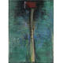 | 294 | Jim Dine, b. 1935 A Red Axe for Alvin With Lots of Thanx  pastel and oil on paper  Read Condition Report | 45,000 – 65,000 USD  UNSOLD
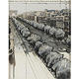 | 295 | Christo, 1935 Wrapped Trees (Project for the Champs-Elysées and the Rond Point du Champs-Elysées Paris)  pencil, polyethylene, twine, wax crayon, photograph by Harry Shunk, pastel and charcoal  Read Condition Report | 80,000 – 120,000 USD  SOLD FOR  98,500 $
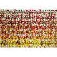 | 296 | Arman, 1928-2005 Untitled (Diptych)  acrylic and paint tubes on canvas, in 2 parts, mounted on panel  Read Condition Report | 150,000 – 200,000 USD  UNSOLD
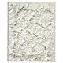 | 297 | Arman, 1928-2005 Monochrome Accumulation No. 2509  acrylic and paint tubes on canvas laid down on board  Read Condition Report | 30,000 – 40,000 USD  SOLD FOR  31,250 $
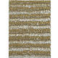 | 298 | Arman, 1928-2005 Puristic Monochrome  acrylic paint and paint tubes in Plexiglas  Read Condition Report | 70,000 – 100,000 USD  UNSOLD
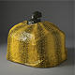 | 299 | Yayoi Kusama, b. 1929 Pumpkin  papier mache and colored mixed media  Read Condition Report | 120,000 – 180,000 USD  SOLD FOR  116,500 $
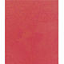 | 300 | Yayoi Kusama, b. 1929 Original Infinity Nets  acrylic on canvas  Read Condition Report | 60,000 – 80,000 USD  SOLD FOR  62,500 $
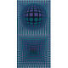 | 301 | Victor Vasarely, 1908-1997 VP-MV  oil on canvas  Read Condition Report | 80,000 – 120,000 USD  UNSOLD

Lot No. | Description | Estimate
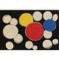 | 302 | Alexander Calder, 1898-1976 Discs on Black  gouache on paper  Read Condition Report | 40,000 – 60,000 USD  SOLD FOR  53,125 $
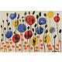 | 303 | Alexander Calder, 1898-1976 Untitled  gouache on paper  Read Condition Report | 40,000 – 60,000 USD  SOLD FOR
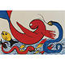 | 304 | Alexander Calder, 1898-1976 Dolphin  gouache on paper  Read Condition Report | 30,000 – 40,000 USD  SOLD FOR
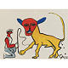 | 305 | Alexander Calder, 1898-1976  Lion and Tamer  gouache on paper  Read Condition Report | 25,000 – 35,000 USD  SOLD FOR

