Impressionist & Modern Art Day Sale including Important Russian Paintings
SALE N08486
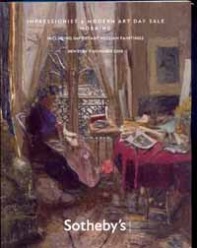

Auction Date
Session 1 | 5 Nov 08, 10:00 AM

Location New York
Listino aggiudicazioni
a s e r v i c e b y www.ArsLife.com
Session 1, ore 10.00 locali, ore 16.00 italiane
lotti 101-264

Lot No. | Description | Estimate
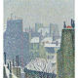 | 101 | Auguste Herbin, 1882-1960 LES TOITS DE PARIS SOUS LA NEIGE  Oil on canvas | 100,000 – 150,000 USD  SOLD FOR 101.500
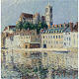 | 102 | Gustave Loiseau, 1865-1935 La Cathédrale à auxerre  Oil on canvas | 100,000 – 150,000 USD  Inizio modulo  UNSOLD
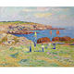 | 103 | Henry Moret, 1856-1913 FOINS AU PORT DE DOËLAN  Oil on canvas  Read Condition Report | 80,000 – 120,000 USD  SOLD FOR 92.500
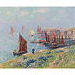 | 104 | Henry Moret, 1856-1913 RENTRÉE DE BATEAUX  Oil on canvas  Read Condition Report | 90,000 – 120,000 USD  SOLD FOR 92.500
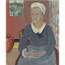 | 105 | Paul Sérusier, 1863-1927 Louise (La servante bretonne)  Gouache on artist's board  Read Condition Report | 80,000 – 120,000 USD  SOLD FOR 92.500
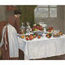 | 106 | Henri Manguin, 1874-1949 JEANNE DEVANT LA NATURE MORTE  Oil on canvas  Read Condition Report | 200,000 – 300,000 USD  UNSOLD
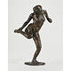 | 107 | Edgar Degas, 1834-1917 Danseuse regardant la plante de son pied droit (Troisième étude)  Bronze  Read Condition Report | 400,000 – 600,000 USD  SOLD FOR 485.500
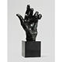 | 108 | Auguste Rodin, 1840-1917 Esquisse de main gauche pour Pierre et Jacques de Wiessant  Bronze  Read Condition Report | 50,000 – 70,000 USD  SOLD FOR 86.500
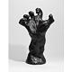 | 110 | Auguste Rodin, 1840-1917 La Grande Main Crispée  Bronze  Read Condition Report | 100,000 – 150,000 USD  SOLD FOR 158.500
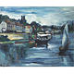 | 110A | Maurice de Vlaminck, 1876-1958  BORD DE RIVIÈRE, LE 14 JUILLET  Oil on canvas  Read Condition Report | 300,000 – 500,000 USD  SOLD FOR 326.500
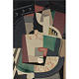 | 111 | María Blanchard, 1881-1932 Femme assise  Oil on canvas  Read Condition Report | 250,000 – 350,000 USD  SOLD FOR 392.500
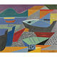 | 112 | André Lhote, 1885-1962  BARQUES SUR LA GRÈVE  Oil on canvas  Read Condition Report | 60,000 – 80,000 USD  UNSOLD
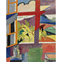 | 113 | André Lhote, 1885-1962  VUE DE FENÊTRE  Oil on canvas  Read Condition Report | 40,000 – 60,000 USD  SOLD FOR 43.750
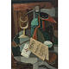 | 114 | Louis Marcoussis, 1883-1941 Nature Morte au menu et au siphon  Oil on canvas  Read Condition Report | 200,000 – 300,000 USD  UNSOLD
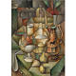 | 115 | Jean Metzinger, 1883-1956  Compotier et cruche décorée de cerfs  Oil on canvas  Read Condition Report | 400,000 – 600,000 USD  SOLD FOR 422.500
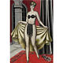 | 116 | Jean Metzinger, 1883-1956  Salomé  Oil on canvas  Read Condition Report | 200,000 – 300,000 USD  UNSOLD
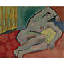 | 117 | André Lhote, 1885-1962 Femme nue allongée  Oil on canvas  Read Condition Report | 40,000 – 60,000 USD  UNSOLD
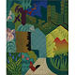 | 118 | André Lhote, 1885-1962 Paysage au coq  Oil on canvas  Read Condition Report | 50,000 – 70,000 USD  UNSOLD
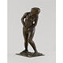 | 119 | Edgar Degas, 1834-1917 FEMME SURPRISE  Bronze  Read Condition Report | 200,000 – 300,000 USD  UNSOLD
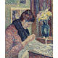 | 120 | Maximilien Luce, 1858-1941 FEMME COUSANT  Oil on canvas  Read Condition Report | 150,000 – 200,000 USD  UNSOLD
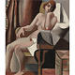 | 121 | André Lhote, 1885-1962 NU ASSIS  Oil on canvas  Read Condition Report | 60,000 – 80,000 USD  UNSOLD
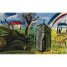 | 122 | Raoul Dufy, 1877-1953 L'ARC-EN-CIEL AU DESSUS DE ST. DENIS SUR SARTHON, NORMANDY  Oil on board  Read Condition Report | 40,000 – 60,000 USD  UNSOLD
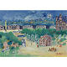 | 123 | Jean Dufy, 1888-1964  VUE DE TUILERIES ET PLACE DE LA CONCORDE  Oil on canvas  Read Condition Report | 40,000 – 60,000 USD  SOLD FOR 53.125
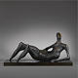 | 124 | Henry Moore, 1898-1986 RECLINING FIGURE  Bronze  Read Condition Report | 700,000 – 900,000 USD  UNSOLD
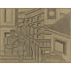 | 125 | Fernand Léger, 1881-1955 Esquisse pour paysage animé  Pencil and grey wash on paper laid down on card  Read Condition Report | 300,000 – 400,000 USD  UNSOLD
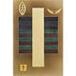 | 126 | Wassily Kandinsky, 1866-1944 VERTIKAL (VERTICAL)  Watercolor, Spritztechnik and gouache on paper laid down on card  Read Condition Report | 250,000 – 350,000 USD  SOLD FOR 206.500
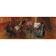 | 127 | Raoul Dufy, 1877-1953  LE QUINTETTE DE MUSIQUE ANCIENNE  Oil on board  Read Condition Report | 60,000 – 80,000 USD  SOLD FOR 68.500
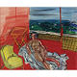 | 128 | Raoul Dufy, 1877-1953 NU DANS L'ATELIER DE VENCE  Oil on canvas  Read Condition Report | 50,000 – 70,000 USD  UNSOLD
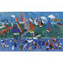 | 129 | Raoul Dufy, 1877-1953 La visite de l'escadre anglaise au Havre  Gouache and watercolor on paper  Read Condition Report | 200,000 – 300,000 USD  UNSOLD
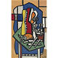 | 130 | Fernand Léger, 1881-1955 Nature Morte au Fruit  Oil on canvas  Read Condition Report | 400,000 – 600,000 USD  SOLD FOR 446.500
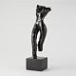 | 131 | Henri Matisse, 1869-1954 Torse Debout  Bronze  Read Condition Report | 200,000 – 300,000 USD  UNSOLD
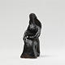 | 132 | Pablo Picasso, 1881-1973 Femme assise  Bronze  Read Condition Report | 20,000 – 30,000 USD  UNSOLD
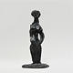 | 133 | Pablo Picasso, 1881-1973 Femme debout  Bronze  Read Condition Report | 40,000 – 60,000 USD  Inizio modulo  SOLD FOR 50.000
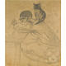 | 134 | Tsuguharu Foujita, 1886-1968 L'ARTISTE ET SON CHAT  Pencil and charcoal on paper  Read Condition Report | 100,000 – 150,000 USD  UNSOLD
 | 135 | - Marie Laurencin, 1883-1956 TROIS JEUNES FILLES  Oil on canvas  Read Condition Report | 150,000 – 200,000 USD  SOLD FOR 158.500
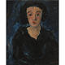 | 136 | Chaim Soutine, 1893-1943 Portrait de femme de face  Oil on canvas  Read Condition Report | 800,000 – 1,200,000 USD  UNSOLD
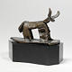 | 137 | Pablo Picasso, 1881-1973 Taureau  Bronze  Read Condition Report | 300,000 – 400,000 USD  Inizio modulo  UNSOLD
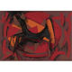 | 138 | Marino Marini, 1901-1980 Cavallo  Oil, gouache and pen and ink on paper laid down on canvas  Read Condition Report | 200,000 – 300,000 USD  UNSOLD
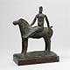 | 139 | Marino Marini, 1901-1980 Piccolo cavaliere  Bronze  Read Condition Report | 200,000 – 300,000 USD  UNSOLD
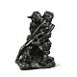 | 140 | Auguste Rodin, 1840-1917  MINOTAURE, VERSION AUX CORNES DROITES  Bronze  Read Condition Report | 250,000 – 350,000 USD  SOLD FOR 278.500
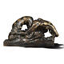 | 141 | Auguste Rodin, 1840-1917 LE POÈTE ET LA SIRÈNE, DEUXIÈME VERSION, or LA VAGUE  Bronze  Read Condition Report | 80,000 – 120,000 USD  UNSOLD
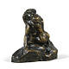 | 142 | Auguste Rodin, 1840-1917 BACCHANTES ENLACÉES, PETIT MODÈLE  Bronze  Read Condition Report | 80,000 – 120,000 USD  UNSOLD
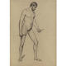 | 143 | Paul Cézanne, 1839-1906 ACADÉMIE D'HOMME  Charcoal on paper  Read Condition Report | 30,000 – 40,000 USD  SOLD FOR 50.000
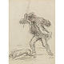 | 144 | Honoré Daumier, 1808 - 1879  Homme battant son chien  Pen and black and red ink on paper  Read Condition Report | 70,000 – 90,000 USD  UNSOLD
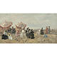 | 145 | Eugène Boudin, 1824-1898 VILLERS, SCÈNE DE PLAGE  Oil on panel  Read Condition Report | 400,000 – 600,000 USD  SOLD FOR 362.500  Inizio modulo
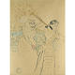 | 146 | Henri de Toulouse-Lautrec, 1864-1901 LES DEUX SOEURS LÉGENDAIRES  Gouache and watercolor over blue crayon on card  Read Condition Report | 300,000 – 400,000 USD  UNSOLD
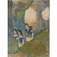 | 147 | Edgar Degas, 1834-1917 DANSEUSES DANS LES COULISSES  Pastel over etching and aquatint on paper  Read Condition Report | 300,000 – 400,000 USD  Inizio modulo  SOLD FOR 242.500
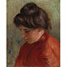 | 148 | Pierre-Auguste Renoir, 1841-1919  Gabrielle  Oil on canvas  Read Condition Report | 500,000 – 700,000 USD  UNSOLD
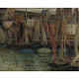 | 149 | Henri le Sidaner, 1862-1939  Bateaux à Tréport  Oil on canvas  Read Condition Report | 125,000 – 175,000 USD  UNSOLD
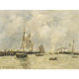 | 150 | Eugène Boudin, 1824-1898 TROUVILLE. LES JETÉES. MARÉE HAUTE  Oil on panel  Read Condition Report | 100,000 – 150,000 USD  UNSOLD
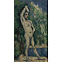 | 151 | Paul Cézanne, 1839-1906 BAIGNEUR DEBOUT  Oil on canvas  Read Condition Report | 400,000 – 600,000 USD  SOLD FOR 572.500
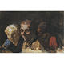 | 152 | Honoré Daumier, 1808 - 1879 Trois Spectateurs  Watercolor, gouache and pen and ink on paper  Read Condition Report | 200,000 – 300,000 USD  UNSOLD
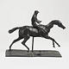 | 153 | Edgar Degas, 1834-1917  Cheval au galop sur le pied droit  Bronze  Read Condition Report | 400,000 – 600,000 USD  UNSOLD
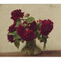 | 154 | Henri Fantin-Latour, 1836-1904 ROSES FONCÉES  Oil on canvas  Read Condition Report | 400,000 – 600,000 USD  Inizio modulo  SOLD FOR 452.500
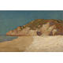 | 155 | Odilon Redon, 1840-1916 Paysage de Bretagne  Oil on cradled panel  Read Condition Report | 40,000 – 60,000 USD  Inizio modulo  SOLD FOR 34.375
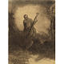 | 156 | Odilon Redon, 1840-1916 Le Centaure au Violoncelle  Charcoal on paper  Read Condition Report | 100,000 – 150,000 USD  UNSOLD
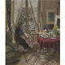 | 157 | Édouard Vuillard, 1868-1940 MADAME VUILLARD un jour de neige  Glue-based distemper on card  Read Condition Report | 1,000,000 – 1,500,000 USD  Inizio modulo  SOLD FOR 962.500
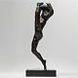 | 158 | Auguste Rodin, 1840-1917 Mouvement de danse, étude type G  Bronze  Read Condition Report | 50,000 – 70,000 USD  Inizio modulo  SOLD FOR 50.000
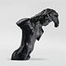 | 159 | Auguste Rodin, 1840-1917 Figure de femme à mi-corps  Bronze  Read Condition Report | 80,000 – 120,000 USD  UNSOLD
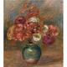 | 160 | Pierre-Auguste Renoir, 1841-1919 BOUQUET DE FLEURS DANS UN VASE VERT  Oil on canvas  Read Condition Report | 500,000 – 700,000 USD  UNSOLD
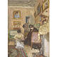 | 161 | Édouard Vuillard, 1868-1940  LE LACET DE LA BOTTINE  Oil on card  Read Condition Report | 300,000 – 500,000 USD  Inizio modulo  SOLD FOR 422.500
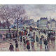 | 162 | Maximilien Luce, 1858-1941 Paris, le pont de l'Archevêché  Oil on canvas  Read Condition Report | 700,000 – 900,000 USD  UNSOLD
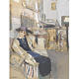 | 163 | Édouard Vuillard, 1868-1940  Le modèle au chapeau violet  Gouache, distemper and pastel on card  Read Condition Report | 100,000 – 150,000 USD  UNSOLD
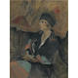 | 164 | Édouard Vuillard, 1868-1940  Annette Salomon  Pastel on grey paper laid down on board  Read Condition Report | 100,000 – 150,000 USD  UNSOLD
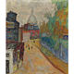 | 165 | - Pierre Bonnard, 1867-1947 Rue à Montmartre, Le Sacré-Coeur  Oil on canvas  Read Condition Report | 500,000 – 700,000 USD  Inizio modulo  SOLD FOR 458.500
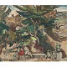 | 166 | - Émile Othon Friesz, 1879-1949 Le jardin  Oil on canvas  Read Condition Report | 30,000 – 40,000 USD  Inizio modulo  SOLD FOR 31.250
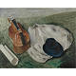 | 167 | - André Derain, 1880-1954  Nature morte au chapeau bleu  Oil on canvas  Read Condition Report | 80,000 – 120,000 USD  Inizio modulo  SOLD FOR 86.500
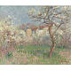 | 168 | Gustave Loiseau, 1865-1935 Printemps, environs de Pontoise  Oil on canvas  Read Condition Report | 70,000 – 90,000 USD  Inizio modulo  SOLD FOR 80.500
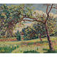 | 169 | Jean-Baptiste-Armand Guillaumin, 1841-1927 Paysage  Oil on canvas  Read Condition Report | 35,000 – 45,000 USD  Inizio modulo  SOLD FOR 46.875
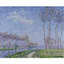 | 170 | Gustave Loiseau, 1865-1935 ARBRES AU BORD DE RIVIèRE  Oil on canvas  Read Condition Report | 180,000 – 250,000 USD  Inizio modulo  SOLD FOR 218.500
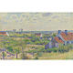 | 171 | Théo van Rysselberghe, 1862-1926 Paysage avec maisons  oil on canvas  Read Condition Report | 700,000 – 900,000 USD  UNSOLD
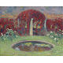 | 172 | Henri Martin, 1860-1943 LE BASSIN ET LA TONNELLE  Oil on canvas  Read Condition Report | 200,000 – 300,000 USD  UNSOLD
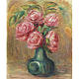 | 173 | Pierre-Auguste Renoir, 1841-1919 VASE DE FLEURS  Oil on canvas  Read Condition Report | 250,000 – 350,000 USD  UNSOLD
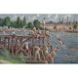 | 174 | Maximilien Luce, 1858-1941 LA BAIGNADE  Oil on canvas  Read Condition Report | 50,000 – 70,000 USD  UNSOLD
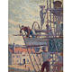 | 175 | Maximilien Luce, 1858-1941  L'ÉCHAFAUDAGE, ÉTUDE  Oil on paper laid down on canvas  Read Condition Report | 60,000 – 80,000 USD  UNSOLD
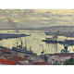 | 176 | - Albert Marquet, 1875-1947 Le Port d'Alger par Temps Gris  Oil on canvas  Read Condition Report | 70,000 – 90,000 USD  Inizio modulo  SOLD FOR 92.500
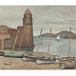 | 177 | Albert Marquet, 1875-1947 LE PHARE DE COLLIOURE  Oil on canvas  Read Condition Report | 180,000 – 250,000 USD  UNSOLD
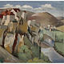 | 178 | André Lhote, 1885-1962 CALVIGNAC  Oil on panel  Read Condition Report | 30,000 – 40,000 USD  UNSOLD
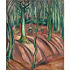 | 179 | Émile Othon Friesz, 1879-1949 LA FORÊT EN AUTOMNE  Oil on canvas  Read Condition Report | 50,000 – 70,000 USD  Inizio modulo  SOLD FOR 53.125
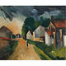 | 180 | Maurice de Vlaminck, 1876-1958 La promenade  Oil on canvas  Read Condition Report | 70,000 – 90,000 USD  Inizio modulo  SOLD FOR 80.500
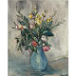 | 181 | Maurice de Vlaminck, 1876-1958 Bouquet au pot bleu  Oil on canvas  Read Condition Report | 140,000 – 180,000 USD  UNSOLD
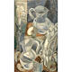 | 182 | André Masson, 1896-1987 LA BOUGIE ALLUMÉE  Oil on canvas  Read Condition Report | 250,000 – 350,000 USD  UNSOLD
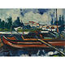 | 183 | Maurice de Vlaminck, 1876-1958  Péniche sur la rivière  Oil on canvas  Read Condition Report | 700,000 – 900,000 USD  UNSOLD
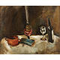 | 184 | Chaim Soutine, 1893-1943 NATURE MORTE À LA LAMPE  Oil on canvas  Read Condition Report | 300,000 – 400,000 USD  UNSOLD
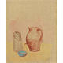 | 185 | Pablo Picasso, 1881-1973 Coupe, Cruche et boite à lait  Watercolor on paper  Read Condition Report | 220,000 – 280,000 USD  SOLD FOR 452.500
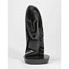 | 186 | Henri Laurens, 1885-1954 Tête de femme  Bronze  Read Condition Report | 200,000 – 300,000 USD  UNSOLD
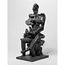 | 187 | Ossip Zadkine, 1890-1967 Le messager, or Le donateur  Bronze  Read Condition Report | 40,000 – 60,000 USD  UNSOLD
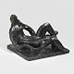 | 188 | Henri Laurens, 1885-1954 L'architecture  Bronze  Read Condition Report | 90,000 – 120,000 USD  UNSOLD
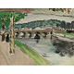 | 189 | Henri Matisse, 1869-1954 Pont de Sèvres, la platane  Oil on canvas  Read Condition Report | 500,000 – 700,000 USD  UNSOLD
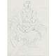 | 190 | Henri Matisse, 1869-1954  LA DANSEUSE  Pencil on paper  Read Condition Report | 60,000 – 80,000 USD  UNSOLD
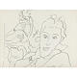 | 191 | Henri Matisse, 1869-1954 FEMME DEVANT UN MIROIR  Pen and ink on paper  Read Condition Report | 60,000 – 80,000 USD  Inizio modulo  SOLD FOR 56.250
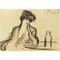 | 192 | Pablo Picasso, 1881-1973 LA BUVEUSE D'ABSINTHE  Colored crayon and black crayon on paper laid down on board  Read Condition Report | 100,000 – 150,000 USD  Inizio modulo  SOLD FOR 74.500
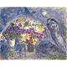 | 193 | Marc Chagall, 1887-1985 LES BOUQUETS DANS LE CIEL  Oil and tempera on canvas  Read Condition Report | 800,000 – 1,200,000 USD  Inizio modulo  SOLD FOR 818.500
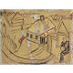 | 194 | Marc Chagall, 1887-1985 Le peintre et son village Lyosno  Pen and ink, gouache and watercolor on paper laid down on the artist's board  Read Condition Report | 280,000 – 350,000 USD  UNSOLD
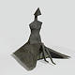 | 195 | Lynn Chadwick, 1914-2003 Sitting Woman in Robes IV  Bronze  Read Condition Report | 120,000 – 180,000 USD  UNSOLD
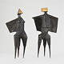 | 196 | Lynn Chadwick, 1914-2003 TWO WINGED FIGURES  Bronze  Read Condition Report | 80,000 – 120,000 USD  UNSOLD
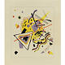 | 197 | Wassily Kandinsky, 1866-1944 Ohne Titel (UNTITLED)  Watercolor and brush and ink over pencil on paper  Read Condition Report | 300,000 – 400,000 USD  SOLD FOR 242.500
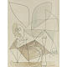 | 198 | Pablo Picasso, 1881-1973 HIBOU ATTAQUANT UN CHAT  Watercolor and pencil on paper  Read Condition Report | 450,000 – 550,000 USD  UNSOLD
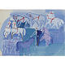 | 199 | Raoul Dufy, 1877-1953 Chevaux de cirque  Watercolor and gouache on card  Read Condition Report | 120,000 – 180,000 USD  Inizio modulo  SOLD FOR 134.500
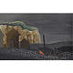 | 200 | Georges Braque, 1882-1963  PLAGE AUX CABINES  Oil on canvas  Read Condition Report | 150,000 – 200,000 USD  Inizio modulo  SOLD FOR 134.500
Lot No. | Description | Estimate
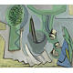 | 201 | Francisco Bores, 1898-1972 NATURE MORTE AU BOL  Oil on canvas  Read Condition Report | 35,000 – 45,000 USD  SOLD FOR 37.500
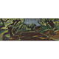 | 202 | Georges Braque, 1882-1963 CHEMIN à LA CIOTAT  Oil on canvas  Read Condition Report | 60,000 – 80,000 USD  UNSOLD
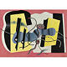 | 203 | Fernand Léger, 1881-1955 Nature morte  Oil on canvas  Read Condition Report | 800,000 – 1,200,000 USD  SOLD FOR 662.500
 | 204 | Marc Chagall, 1887-1985 LE MARIAGE  Gouache, pen and ink and ink wash on paper  Read Condition Report | 400,000 – 600,000 USD  UNSOLD
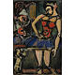 | 205 | - Georges Rouault, 1871-1958  ANTINéA (DANSEUSE ET CLOWNS)  Oil on paper laid down on canvas  Read Condition Report | 60,000 – 80,000 USD  SOLD FOR 53.125
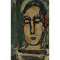 | 206 | Georges Rouault, 1871-1958 PIERROT  Oil on paper laid down on canvas  Read Condition Report | 80,000 – 120,000 USD  UNSOLD
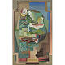 | 207 | Louis Marcoussis, 1883-1941 La Table  Gouache on paper laid down on canvas  Read Condition Report | 300,000 – 400,000 USD  UNSOLD
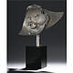 | 208 | Pablo Gargallo, 1881-1934 MASQUE D'ARLEQUIN SOURIANT III  Copper  Read Condition Report | 550,000 – 750,000 USD  UNSOLD
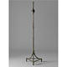 | 209 | Alberto and Diego Giacometti, 1901-1966 and 1902-1985  Lampadaire à noeud  Bronze  Read Condition Report | 70,000 – 90,000 USD  SOLD FOR 116.500
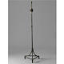 | 210 | Alberto and Diego Giacometti, 1901-1966 and 1902-1985  LAMPADAIRE À NOEUD  Bronze  Read Condition Report | 70,000 – 90,000 USD  SOLD FOR 116.500
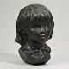 | 211 | Pierre-Auguste Renoir, 1841-1919  Tête de Coco  Bronze  Read Condition Report | 20,000 – 30,000 USD  SOLD FOR 22.500
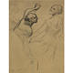 | 212 | Edgar Degas, 1834-1917  Trois danseuses  Charcoal and pastel on paper laid down on card  Read Condition Report | 70,000 – 90,000 USD  SOLD FOR 56.250
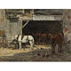 | 213 | Eugène Boudin, 1824-1898 Cour et écurie d'un loueur  Oil on panel  Read Condition Report | 25,000 – 35,000 USD  UNSOLD
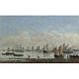 | 214 | Eugène Boudin, 1824-1898  CAMARET, BATEAUX DE PÊCHE ANCRÉS DANS LA RADE  Oil on canvas  Read Condition Report | 70,000 – 90,000 USD  UNSOLD
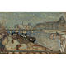 | 215 | Pierre Bonnard, 1867-1947 Les quais de Paris  Oil on board laid down on cradled panel  Read Condition Report | 500,000 – 700,000 USD  UNSOLD
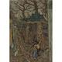 | 216 | Pierre Bonnard, 1867-1947  Montmartre, Vieil Homme et Enfant  Oil on canvas  Read Condition Report | 70,000 – 90,000 USD  SOLD FOR 86.500
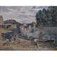 | 217 | Jean-Baptiste-Armand Guillaumin, 1841-1927  LE PONT DE SULLY, PARIS  Oil on canvas  Read Condition Report | 150,000 – 200,000 USD  UNSOLD
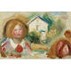 | 218 | Pierre-Auguste Renoir, 1841-1919 ÉTUDES, TÊTES ET MAISONS  Oil on canvas  Read Condition Report | 100,000 – 150,000 USD  UNSOLD
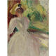 | 219 | Pierre-Auguste Renoir, 1841-1919 Portrait de femme  Oil on canvas  Read Condition Report | 150,000 – 200,000 USD  UNSOLD
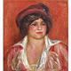 | 220 | Pierre-Auguste Renoir, 1841-1919 JEUNE FEMME AU CHAPEAU  Oil on canvas  Read Condition Report | 400,000 – 600,000 USD  UNSOLD
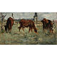 | 221 | Edouard Manet, 1832-1883  VACHES AU PÂTURAGE  Oil on panel  Read Condition Report | 80,000 – 120,000 USD  SOLD FOR 86.500
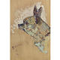 | 222 | Henri de Toulouse-Lautrec, 1864-1901  Boulou  Oil on panel  Read Condition Report | 150,000 – 200,000 USD  UNSOLD
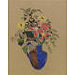 | 223 | Odilon Redon, 1840-1916 Vase de fleurs  Pastel and charcoal on paper  Read Condition Report | 400,000 – 600,000 USD  UNSOLD
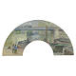 | 224 | Camille Pissarro, 1830-1903  LE PONT DE CHEMIN DE FER à PONTOISE  Gouache and watercolor on silk laid down on card  Read Condition Report | 200,000 – 300,000 USD  UNSOLD
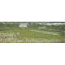 | 225 | Édouard Vuillard, 1868-1940 PRAIRIE AU BORD DE LA MER à LOCTUDY  Distemper, pastel and pencil on paper laid down on canvas  Read Condition Report | 150,000 – 200,000 USD  SOLD FOR 110.500
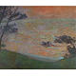 | 226 | Henri Martin, 1860-1943 Coucher de soleil au bord de la mer  Oil on canvas  Read Condition Report | 800,000 – 1,200,000 USD  UNSOLD
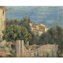 | 227 | Pierre-Auguste Renoir, 1841-1919 LA MAISON DE L'ARTISTE à CAGNES  Oil on canvas  Read Condition Report | 300,000 – 400,000 USD  SOLD FOR 302.500
 | 228 | Marie-Louise-Catherine Breslau, 1856-1927  Portrait de fillette  Pastel on paper  Read Condition Report | 15,000 – 20,000 USD  UNSOLD
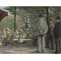 | 229 | Charles Maurin, 1856-1914 SCÈNE DE GUIGNOL EN PLEIN AIR  Pastel and charcoal on paper  Read Condition Report | 15,000 – 20,000 USD  UNSOLD
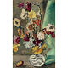 | 230 | Louis Valtat, 1869-1952 Immortelles au petit vase de crystal  Oil on canvas  Read Condition Report | 18,000 – 22,000 USD  SOLD FOR 28.125
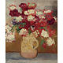 | 231 | Louis Valtat, 1869-1952 Bouquet de fleurs  Oil on canvas  Read Condition Report | 50,000 – 70,000 USD  UNSOLD
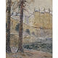 | 232 | Gustave Loiseau, 1865-1935 Le pont marie, effet de neige  Oil on canvas  Read Condition Report | 60,000 – 80,000 USD  UNSOLD
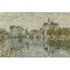 | 233 | Gustave Loiseau, 1865-1935 Moret-sur-Loing  Oil on canvas  Read Condition Report | 60,000 – 80,000 USD  UNSOLD
 | 234 | Maurice de Vlaminck, 1876-1958 LE LAC  Oil on canvas  Read Condition Report | 300,000 – 400,000 USD  SOLD FOR 338.500
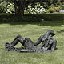 | 235 | Ossip Zadkine, 1890-1967 Statue pour jardin  Bronze  Read Condition Report | 200,000 – 300,000 USD  SOLD FOR 212.500
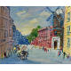 | 236 | Jean Dufy, 1888-1964 LE MOULIN DE LA GALETTE  Oil on canvas  Read Condition Report | 30,000 – 40,000 USD  UNSOLD
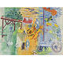 | 237 | Raoul Dufy, 1877-1953 La Ferme  Gouache and watercolor on paper  Read Condition Report | 40,000 – 60,000 USD  UNSOLD
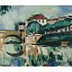 | 238 | Maurice de Vlaminck, 1876-1958 LE PONT DE POISSY  Oil on canvas  Read Condition Report | 400,000 – 600,000 USD  UNSOLD
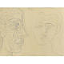 | 239 | Pablo Picasso, 1881-1973  DEUX TÊTES  Pen and ink on paper  Read Condition Report | 250,000 – 350,000 USD  UNSOLD
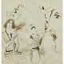 | 240 | Marc Chagall, 1887-1985  La nuit se mêle au jour, étude  Pen and ink, ink wash and pencil on paper  Read Condition Report | 30,000 – 40,000 USD  UNSOLD
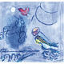 | 241 | Marc Chagall, 1887-1985  ESQUISSE POR ALEKO ET ZEMPHIRA AU CLAIR DE LUNE  Gouache and pastel on paper  Read Condition Report | 50,000 – 70,000 USD  SOLD FOR 80.500
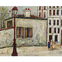 | 242 | Maurice Utrillo, 1883-1955 LA MAISON DE BERLIOZ à MONTMARTRE  Oil on board  Read Condition Report | 70,000 – 90,000 USD  SOLD FOR 62.500
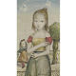 | 244 | Tsuguharu Foujita, 1886-1968 Les Deux Soeurs  Oil on board  Read Condition Report | 150,000 – 200,000 USD  SOLD FOR 134.500
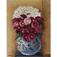 | 245 | Moïse Kisling, 1891-1953 Fleurs sur fond jaune  Oil on canvas  Read Condition Report | 40,000 – 60,000 USD  SOLD FOR 43.750
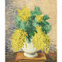 | 246 | Moïse Kisling, 1891-1953 BOUQUET DE MIMOSAS  Oil on canvas  Read Condition Report | 90,000 – 120,000 USD  UNSOLD
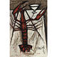 | 247 | Bernard Buffet, 1928-1999 HOMARD  Oil on canvas  Read Condition Report | 50,000 – 70,000 USD  SOLD FOR 62.500
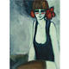 | 248 | Jean-Pierre Cassigneul, b. 1935 DANSEUSE  Oil on canvas  Read Condition Report | 60,000 – 80,000 USD  UNSOLD
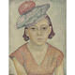 | 249 | Marie Vorobieff Marevna, (1892-1984) PORTRAIT OF MARIKA  Oil on panel  Read Condition Report | 20,000 – 30,000 USD  SOLD FOR 37.500
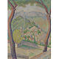 | 250 | Marie Vorobieff Marevna, 1892-1984 CAGNES  Oil on canvas  Read Condition Report | 25,000 – 35,000 USD  SOLD FOR 37.500
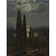 | 251 | Nikolai Nikanorovich Dubovskoy, Russian 1859-1918 Night on the Southern Shore  Oil on canvas  Read Condition Report | 400,000 – 600,000 USD  UNSOLD
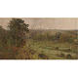 | 252 | Nikolai Nikanorovich Dubovskoy, Russian 1859-1918 Summer Has Ended  Oil on canvas  Read Condition Report | 500,000 – 700,000 USD  UNSOLD
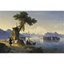 | 253 | Ivan Konstantinovich Aivazovsky, Russian 1817-1900 Isola Bella on Lake Maggiore  Oil on canvas  Read Condition Report | 1,800,000 – 2,200,000 USD  UNSOLD
 | 254 | Alexei Petrovich Bogoliubov, Russian 1824-1896 View of St. Petersburg  Oil on canvas  Read Condition Report | 2,000,000 – 3,000,000 USD  UNSOLD
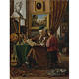 | 255 | Vladimir Egorovich Makovsky, Russian 1846-1920 Three Generations  Oil on canvas  Read Condition Report | 400,000 – 600,000 USD  UNSOLD
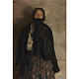 | 256 | Philip Andreevich Maliavin, Russian 1869-1940 Peasant, Covering her Mouth with a Shawl  Oil on canvas  Read Condition Report | 600,000 – 800,000 USD  SOLD FOR 602.500
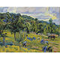 | 257 | Nicolas Tarkhoff, Russian 1871-1920 Les Travaux des Champs  Oil on board  Read Condition Report | 300,000 – 400,000 USD  UNSOLD
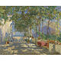 | 258 | Konstantin Ivanovich Gorbatov, Russian 1876-1945 Patio in Capri  Oil on canvas  Read Condition Report | 250,000 – 350,000 USD  SOLD FOR 392.500
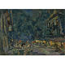 | 259 | Konstantin Alexeevich Korovin, Russian 1861-1939 Vichy  Oil on canvas  Read Condition Report | 500,000 – 700,000 USD  SOLD FOR 302.500
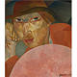 | 260 | Boris Dmitrievich Grigoriev, Russian 1886-1939  Russian Man  Oil on canvas  Read Condition Report | 600,000 – 800,000 USD  SOLD FOR 602.500
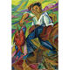 | 261 | David Davidovich Burliuk, Russian 1882-1967 Japanese Fisherman  Oil on board  Read Condition Report | 500,000 – 700,000 USD  SOLD FOR 542.500
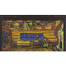 | 262 | Nicholas Roerich, Russian 1874-1947 Russian Hut from The Tale of Tsar Saltan  Tempera on canvas  Read Condition Report | 200,000 – 300,000 USD  SOLD FOR 242.500
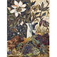 | 263 | Natalia Sergeevna Goncharova, Russian 1881-1962  Autumn Colors  Oil on board  Read Condition Report | 500,000 – 700,000 USD  SOLD FOR 512.500
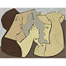 | 264 | Leopold Survage, Russian 1879-1968  Les Vendeuses de Poisson (La Dispute), 1927  Oil on canvas  Read Condition Report | 200,000 – 300,000 USD  SOLD FOR 194.500

