Impressionist & Modern Art Day Sale including Important Russian Paintings
SALE N08486
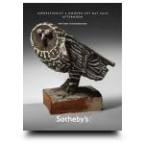

Auction Date
Session 1 | 5 Nov 08, 10:00 AM
Session 2 | 5 Nov 08, 2:00 PM

Location New York
Listino aggiudicazioni
a s e r v i c e b y www.ArsLife.com
Session 2, ore 14.00 locali, ore 20 italiane
Lotti 331-463

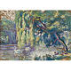 | 301 | Henri-Edmond Cross, 1856-1910 FAMILLE DE CYGNES (LE BOIS DE BOULOGNE)  Oil on panel  Read Condition Report | 60,000 – 80,000 USD  UNSOLD
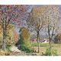 | 302 | Pierre-Eugène Montézin, 1874-1946 LE CHEMIN  Oil on canvas  Read Condition Report | 55,000 – 75,000 USD  SOLD FOR 46.875
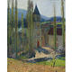 | 303 | Henri Martin, 1860-1943 L'église de Labastide-du-Vert, fin d'après-midi  Oil on canvas  Read Condition Report | 80,000 – 120,000 USD  SOLD FOR 92.500
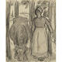 | 304 | Camille Pissarro, 1830-1903 La vachère  Pencil, charcoal and ink wash on paper  Read Condition Report | 30,000 – 40,000 USD  UNSOLD
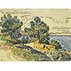 | 305 | Paul Signac, 1863-1935 PAYSAGE CÔTIER AUX ARBRES  Watercolor, pen and ink and pencil on paper laid down on card  Read Condition Report | 50,000 – 70,000 USD  SOLD FOR 53.125
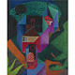 | 306 | Jean Metzinger, 1883-1956 MAISON CUBISTE au bord de l'eau  Oil on canvas  Read Condition Report | 350,000 – 450,000 USD  UNSOLD
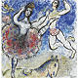 | 307 | Marc Chagall, 1887-1985  L'écuyère à la jupe fleurie ou le numéro de voltige  Gouache, pen and ink, ink wash and colored crayon on paper  Read Condition Report | 200,000 – 300,000 USD  UNSOLD
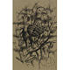 | 308 | Fernand Léger, (1881-1955) PERROQUETS  Pen and ink, ink wash and pencil on paper  Read Condition Report | 70,000 – 90,000 USD  UNSOLD
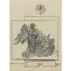 | 309 | Max Ernst, 1891-1976 Frottage  Pencil on paper  Read Condition Report | 100,000 – 150,000 USD  UNSOLD
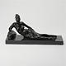 | 310 | Henri Matisse, 1869-1954 Petit Nu au polochon  Bronze  Read Condition Report | 400,000 – 600,000 USD  UNSOLD
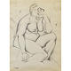 | 311 | Tamara de Lempicka, 1898-1980  NU ASSIS, UN COUDE SUR LE GENOU  Pencil on paper  Read Condition Report | 15,000 – 20,000 USD  SOLD FOR 16.250
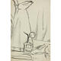 | 312 | Juan Gris, 1887-1927 LE VAPORISATEUR  Charcoal on paper  Read Condition Report | 120,000 – 180,000 USD  UNSOLD
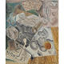 | 313 | André Masson, 1896-1987  Pommes  Oil on canvas  Read Condition Report | 250,000 – 350,000 USD  UNSOLD
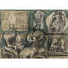 | 314 | Henry Moore, 1898-1986 Mother and Child (Studies)  Figure Studies (a double sided work)  Colored crayon, charcoal, pen & ink and gouache on paper (recto & verso)  Read Condition Report | 50,000 – 70,000 USD  SOLD FOR 47.500
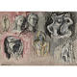 | 315 | Henry Moore, 1898-1986  Heads and Figures and Seated Figures (a double sided work)  Watercolor, pen and ink, ink wash, pencil and wax crayon on paper  Read Condition Report | 40,000 – 60,000 USD  SOLD FOR 36.250
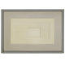 | 316 | Ben Nicholson, O.M., 1894-1982 WHITE RELIEF, PROJECT  Oil on board relief laid down on the artist's prepared board  Read Condition Report | 350,000 – 450,000 USD  SOLD FOR 362.500
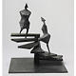 | 317 | Lynn Chadwick, 1914-2003 SPIRAL I  Bronze  Read Condition Report | 60,000 – 80,000 USD  SOLD FOR 68.500
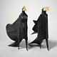 | 318 | Lynn Chadwick, 1914-2003 MAQUETTE I, JUBILEE III  Bronze  Read Condition Report | 100,000 – 150,000 USD  SOLD FOR 152.500
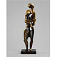 | 319 | Ossip Zadkine, 1890-1967 Castor  Bronze  Read Condition Report | 60,000 – 80,000 USD  SOLD FOR 74.500
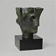 | 320 | Henry Moore, 1898-1986  Study for Head of Queen  Bronze  Read Condition Report | 80,000 – 120,000 USD  UNSOLD
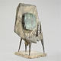 | 321 | Lynn Chadwick, 1914-2003 Composition  Iron, copper and composition on a marble base  Read Condition Report | 200,000 – 300,000 USD  SOLD FOR 200.500
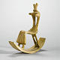 | 322 | Henry Moore, 1898-1986 ROCKING CHAIR NO.3  Plaster with shellac finish  Read Condition Report | 300,000 – 400,000 USD  UNSOLD
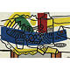 | 323 | Fernand Léger, 1881-1955 Nature Morte en bleu  Oil on canvas  Read Condition Report | 700,000 – 900,000 USD  UNSOLD
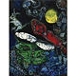 | 324 | Marc Chagall, 1887-1985 CIEL PEUPLÉ  Oil and brush and ink on canvas  Read Condition Report | 300,000 – 400,000 USD  SOLD FOR 314.500
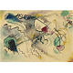 | 325 | Wassily Kandinsky, 1866-1944 OHNE TITEL (UNTITLED)  Watercolor and brush and ink on paper  Read Condition Report | 200,000 – 300,000 USD  SOLD FOR 218.500
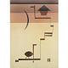 | 326 | Wassily Kandinsky, 1866-1944 ECKIG (ANGULAR)  Watercolor, Spritztechnik and pen and ink on paper laid down on card  Read Condition Report | 500,000 – 700,000 USD  UNSOLD
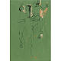 | 327 | Marino Marini, 1901-1980 Cavallo e cavalieri  Gouache and pen and ink on paper  Read Condition Report | 40,000 – 60,000 USD  SOLD FOR 56.250
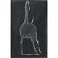 | 328 | Marino Marini, 1901-1980 Cavallo  Gouache and pastel on paper laid down on board  Read Condition Report | 40,000 – 60,000 USD  SOLD FOR 56.250
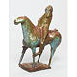 | 329 | Marino Marini, 1901-1980  PICCOLO CAVALIERE  Painted and glazed cast ceramic  Read Condition Report | 300,000 – 400,000 USD  UNSOLD
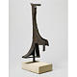 | 330 | Julio González, 1876-1942 Femme Assise III  Bronze  Read Condition Report | 300,000 – 400,000 USD  UNSOLD
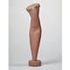 | 331 | Alexander Archipenko, 1887-1964 Torse de femme  Cast stone  Read Condition Report | 50,000 – 70,000 USD  SOLD FOR 50.000
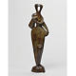 | 332 | Alexander Archipenko, 1887-1964 Statuette  Bronze  Read Condition Report | 80,000 – 120,000 USD  UNSOLD
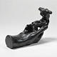 | 333 | Auguste Rodin, 1840-1917 Main de Rodin Tenant un Torse, Type A  Bronze  Read Condition Report | 100,000 – 150,000 USD  SOLD FOR 104.500
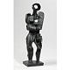 | 334 | Ossip Zadkine, 1890-1967 La Femme Inconnue  Bronze  Read Condition Report | 40,000 – 60,000 USD  SOLD FOR 31.250
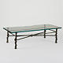 | 335 | Diego Giacometti, 1902-1985 Table aux Torsades  Bronze  Read Condition Report | 150,000 – 200,000 USD  SOLD FOR 218.500
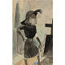 | 336 | Otto Dix, 1891-1969 Trauernde Braut (Mourning Bride)  Watercolor on paper  Read Condition Report | 50,000 – 70,000 USD  SOLD FOR 62.500
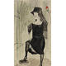 | 337 | Otto Dix, 1891-1969 Witwe Mit Rose (Woman with Rose)  Watercolor on paper  Read Condition Report | 70,000 – 90,000 USD  SOLD FOR 62.500
Lot No. | Description | Estimate
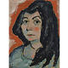 | 338 | Alexej von Jawlensky, 1864-1941 HELENE MIT OFFENEM HAAR (HELENE WITH HER HAIR DOWN)  Oil on board  Read Condition Report | 700,000 – 900,000 USD  UNSOLD
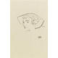 | 339 | Egon Schiele, 1890-1918 POLDI  Black crayon on paper  Read Condition Report | 80,000 – 120,000 USD  UNSOLD
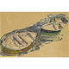 | 340 | Egon Schiele, 1890-1918 DREI RUDERBOOTE (THREE ROWBOATS)  Tempera, gouache and pencil on paper  Read Condition Report | 300,000 – 400,000 USD  UNSOLD
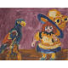 | 341 | Emil Nolde, 1867-1956 PUPPE UND PAPAGEI (DOLL AND PARROT)  Oil on canvas  Read Condition Report | 500,000 – 700,000 USD  UNSOLD
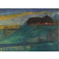 | 342 | Emil Nolde, 1867-1956  Bauernhaus am Kai (Farmhouse on the Wharf)  Watercolor on paper  Read Condition Report | 120,000 – 180,000 USD  SOLD FOR 86.500
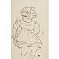 | 343 | Egon Schiele, 1890-1918 SITZENDES MäDCHEN (SITTING GIRL)  Black crayon on paper  Read Condition Report | 120,000 – 180,000 USD  UNSOLD
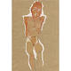 | 344 | Egon Schiele, 1890-1918 MÄNNLICHER AKT MIT VERKÜRZTEN ARMEN (MALE NUDE WITH TRUNCATED ARMS)  Gouache, watercolor and charcoal on paper  Read Condition Report | 800,000 – 1,200,000 USD  UNSOLD
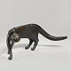 | 345 | Gerhard Marcks, 1889-1981 Laufende Katze (Running Cat)  Bronze  Read Condition Report | 70,000 – 90,000 USD  UNSOLD
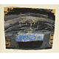 | 346 | Paul Klee, 1879-1940 SKIZZE "KNABENKOPF"  (SKETCH "HEAD OF A BOY")  Tempera on newspaper laid down on the artist's mount  Read Condition Report | 100,000 – 150,000 USD  SOLD FOR 74.500
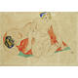 | 347 | Egon Schiele, 1890-1918 LIEGENDE UND SITZENDE WEIBLICHE AKTE AUF ROT-GRÜNEM TUCH (RECLINING AND SEATED FEMALE NUDES ON A RED AND GREEN CLOTH)  Gouache, watercolor and pencil on paper  Read Condition Report | 400,000 – 600,000 USD  SOLD FOR 494.500
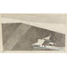 | 348 | Lyonel Feininger, 1871-1956 UNDER SHORTENED SAIL  Watercolor and pen and ink on paper  Read Condition Report | 50,000 – 70,000 USD  SOLD FOR 50.000
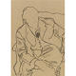 | 349 | Egon Schiele, 1890-1918 Studie von Hugo Koller im Sessel (STUDY OF HUGO KOLLER IN ARMCHAIR)  Black crayon on paper  Read Condition Report | 40,000 – 60,000 USD  UNSOLD
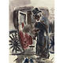 | 350 | George Grosz, 1893-1959 Der Schwarze Kutscher (THE BLACK CABBY)  Watercolor on paper  Read Condition Report | 30,000 – 40,000 USD  UNSOLD
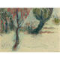 | 351 | Emil Nolde, 1867-1956 Landschaft (LANDSCAPE)  Watercolor and tempera on paper  Read Condition Report | 50,000 – 70,000 USD  UNSOLD
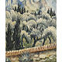 | 352 | Paul Kleinschmidt, 1883-1949  OLIVENBAUME, MAUSANNE, CASSIS  Oil on canvas  Read Condition Report | 30,000 – 40,000 USD  SOLD FOR 37.500
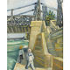 | 353 | Paul Kleinschmidt, 1883-1949 Le Pont de Trinquetaille bei Arles  Oil on canvas  Read Condition Report | 60,000 – 80,000 USD  UNSOLD
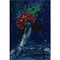 | 354 | Marc Chagall, 1887-1985 LE RÊVE NOCTURNE  Oil and ink wash on board laid down on canvas  Read Condition Report | 450,000 – 650,000 USD  UNSOLD
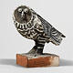 | 355 | Pablo Picasso, 1881-1973 Le Hibou Gris  Handpainted terracotta  Read Condition Report | 700,000 – 900,000 USD  SOLD FOR 1.034.500
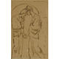 | 356 | Pablo Picasso, 1881-1973 LES DEUX SOEURS  Pen and ink on paper  Read Condition Report | 100,000 – 150,000 USD  UNSOLD
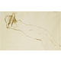 | 357 | Pablo Picasso, 1881-1973 NU COUCHÉ, LE VISAGE CACHÉ  Pen and ink and wash on paper  Read Condition Report | 100,000 – 150,000 USD  UNSOLD
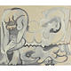 | 358 | Pablo Picasso, 1881-1973 Deux nus et enfant  Oil on prepared panel  Read Condition Report | 700,000 – 900,000 USD  SOLD FOR 710.500
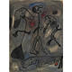 | 359 | Joan Miró, 1893-1983  Figures et chien  Gouache and brush and ink on paper  Read Condition Report | 250,000 – 350,000 USD  UNSOLD
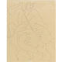 | 360 | Pablo Picasso, 1881-1973 Méléagre tue le sanglier de Calydon  Pencil on card  Read Condition Report | 50,000 – 70,000 USD  UNSOLD
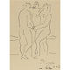 | 361 | Pablo Picasso, 1881-1973  Les trois Graces  Pen and ink on paper  Read Condition Report | 70,000 – 90,000 USD  UNSOLD
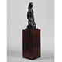 | 362 | Baltasar Lobo, 1910-1993 JEUNE FILLE AUX MAINS CROISÉES  Bronze  Read Condition Report | 60,000 – 80,000 USD  UNSOLD
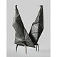 | 363 | Lynn Chadwick, 1914-2003 Conjunction II  Bronze  Read Condition Report | 120,000 – 180,000 USD  UNSOLD
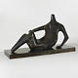 | 364 | Henry Moore, 1898-1986 RECLINING FIGURE: POINTED HEAD  Bronze  Read Condition Report | 700,000 – 900,000 USD  UNSOLD
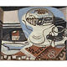 | 365 | Pablo Picasso, 1881-1973 Nature morte, fourchette  Oil on canvas  Read Condition Report | 500,000 – 700,000 USD  UNSOLD
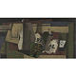 | 367 | Georges Braque, 1882-1963 Le Radical  Oil on canvas  Read Condition Report | 500,000 – 700,000 USD  SOLD FOR 530.500
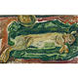 | 369 | Chaim Soutine, 1893-1943 Le lièvre  Oil on canvas  Read Condition Report | 180,000 – 250,000 USD  UNSOLD
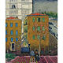 | 370 | Kees van Dongen, 1877- 1968 Boulevards Extérieurs, Paris  Oil on canvas  Read Condition Report | 150,000 – 200,000 USD  SOLD FOR 134.500
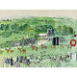 | 371 | Raoul Dufy, 1877-1953 Epsom, le défilé des partants  Watercolor and gouache on paper  Read Condition Report | 250,000 – 350,000 USD  SOLD FOR 266.500
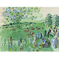 | 372 | Raoul Dufy, 1877-1953 Le champ de courses à Ascot  Watercolor and gouache on paper  Read Condition Report | 300,000 – 400,000 USD  SOLD FOR 302.500
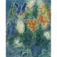 | 373 | Marc Chagall, 1887-1985 Les Amoureux au Bouquet  Gouache, oil, colored crayon and pastel on paper laid down on card  Read Condition Report | 300,000 – 400,000 USD  SOLD FOR 326.500
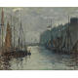 | 374 | Raoul Dufy, 1877-1953 LE BASSIN DE LA BARRE  Oil on panel  Read Condition Report | 20,000 – 30,000 USD  SOLD FOR 22.500
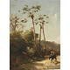 | 375 | Camille Pissarro, 1830-1903 PAYSAGE DES ANTILLES, CAVALIER ET ÂNE SUR UN CHEMIN  Oil on board  Read Condition Report | 70,000 – 90,000 USD  UNSOLD
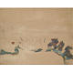 | 376 | Paul Cézanne, 1839-1906 LA ROUTE TOURNANTE À LA ROCHE-GUYON  Oil and pencil on canvas  Read Condition Report | 400,000 – 600,000 USD  UNSOLD
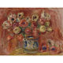 | 377 | Pierre-Auguste Renoir, 1841-1919 BOUQUET DE FLEURS  Oil on canvas  Read Condition Report | 600,000 – 800,000 USD  UNSOLD
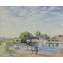 | 378 | Alfred Sisley, 1839-1899 LES OIES à SAINT-MAMMèS  pastel on paper  Read Condition Report | 500,000 – 700,000 USD  UNSOLD
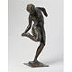 | 379 | Edgar Degas, 1834-1917 DANSEUSE REGARDANT LA PLANTE DE SON PIED DROIT (Première étude)  Bronze  Read Condition Report | 320,000 – 380,000 USD  UNSOLD
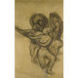 | 380 | Edgar Degas, 1834-1917 GROUPE DE DANSEUSES  Charcoal on paper laid down on board  Read Condition Report | 500,000 – 700,000 USD  SOLD FOR
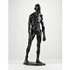 | 381 | Auguste Rodin, 1840-1917  L'un des Bourgeois de Calais: Étude de nu pour Eustache de Saint-Pierre  Bronze  Read Condition Report | 80,000 – 120,000 USD  SOLD FOR 86.500
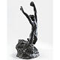 | 382 | Auguste Rodin, 1840-1917  L'ENFANT PRODIGUE, PETIT MODÈLE  Bronze  Read Condition Report | 70,000 – 90,000 USD  UNSOLD
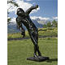 | 383 | Auguste Rodin, 1840-1917  Génie du repos éternel, version avec draperie  Bronze  Read Condition Report | 400,000 – 600,000 USD  UNSOLD
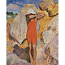 | 384 | Henri Lebasque, 1865-1937 Jeune Enfant au maillot rouge  Oil on canvas  Read Condition Report | 200,000 – 300,000 USD  SOLD FOR 194.500
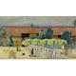 | 385 | Pierre Bonnard, 1867-1947 La Ferme  Oil on canvas  Read Condition Report | 550,000 – 750,000 USD  UNSOLD
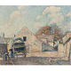 | 386 | Henri Lebasque, 1865-1937 RUE DANS LE VILLAGE  Oil on canvas  Read Condition Report | 60,000 – 80,000 USD  UNSOLD
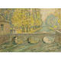 | 387 | Henri le Sidaner, 1862-1939 LE PONT. AUTOMNE, GISORS  Oil, gouache and charcoal on board  Read Condition Report | 100,000 – 150,000 USD  UNSOLD
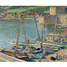 | 388 | Henri Martin, 1860-1943 BATEAUX DE PêCHe, SUR LA GRèVE à COLLIOURE  Oil on canvas  Read Condition Report | 350,000 – 450,000 USD  UNSOLD
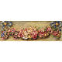 | 389 | Pierre-Auguste Renoir, 1841-1919 GUIRLANDE DE ROSES  Oil on canvas  Read Condition Report | 400,000 – 600,000 USD  SOLD FOR 398.500
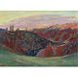 | 390 | Jean-Baptiste-Armand Guillaumin, 1841-1927  Les Ruines du château de crozant  Oil on canvas  Read Condition Report | 100,000 – 150,000 USD  UNSOLD
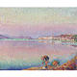 | 391 | Henri Lebasque, 1865-1937 ST TROPEZ, DEUX ENFANTS AU BORD DE L'EAU  Oil on canvas  Read Condition Report | 150,000 – 200,000 USD  UNSOLD
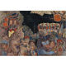 | 393 | Pierre Bonnard, 1867-1947 ARMISTICE  oil on canvas  Read Condition Report | 750,000 – 1,000,000 USD  UNSOLD
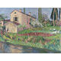 | 394 | Henri Martin, 1860-1943 LA MAISON DE MARIE-LOUISE AU PRINTEMPS à LA BASTIDE-DU-VERT  Oil on canvas  Read Condition Report | 200,000 – 300,000 USD  UNSOLD
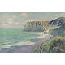 | 395 | Gustave Loiseau, 1865-1935  Les Falaises de Saint-Jouin  Oil on canvas  Read Condition Report | 300,000 – 500,000 USD  UNSOLD
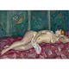 | 396 | Charles Camoin, 1879-1965 Nu couché au paravent fleuri  Oil on canvas  Read Condition Report | 40,000 – 60,000 USD  SOLD FOR 50.000
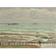 | 397 | - Albert Marquet, 1875-1947 La Digne Ste Beuve à Boulogne-sur-Mer (Au Bord de la Plage)  Oil on canvas  Read Condition Report | 70,000 – 90,000 USD  SOLD FOR 116.500
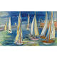 | 398 | Raoul Dufy, 1877-1953 RÉGATES à DEAUVILLE  Oil on panel  Read Condition Report | 300,000 – 400,000 USD  SOLD FOR 278.500
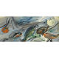 | 399 | Raoul Dufy, 1877-1953 NATURE MORTE AUX POISSONS  Oil on panel  Read Condition Report | 60,000 – 80,000 USD  SOLD FOR 43.750
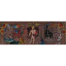 | 400 | Raoul Dufy, 1877-1953 Orphée Charmant les animaux  Oil on canvas  Read Condition Report | 180,000 – 250,000 USD  SOLD FOR 182.500
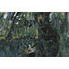 | 401 | Chaim Soutine, 1893-1943 Paysage à Champigny (la mare aux canards)  Oil on canvas  Read Condition Report | 250,000 – 350,000 USD  UNSOLD
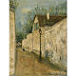 | 402 | Maurice Utrillo, 1883-1955 LA RUE ST VINCENT  Oil on canvas  Read Condition Report | 80,000 – 120,000 USD  UNSOLD
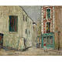 | 403 | Maurice Utrillo, 1883-1955 La Belle Gabrielle et la rue Saint-Vincent  Oil on board  Read Condition Report | 200,000 – 300,000 USD  UNSOLD
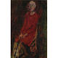 | 404 | Chaim Soutine, 1893-1943 Jeune Femme en rouge  Oil on board laid down on panel  Read Condition Report | 800,000 – 1,200,000 USD  SOLD FOR 830.500
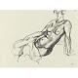 | 405 | Henri Matisse, 1869-1954  Étude de torse  Pen and ink on paper  Read Condition Report | 40,000 – 60,000 USD  UNSOLD
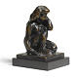 | 406 | Henri Matisse, 1869-1954 Petit Nu accroupi avec bras  Bronze  Read Condition Report | 180,000 – 250,000 USD  UNSOLD
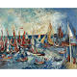 | 407 | Jean Dufy, 1888-1964  L'Île d'Yeu  Oil on canvas  Read Condition Report | 40,000 – 60,000 USD  UNSOLD
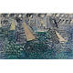 | 408 | Raoul Dufy, 1877-1953 VOILIERS  Oil on canvas  Read Condition Report | 100,000 – 150,000 USD  SOLD FOR 86.500
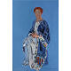 | 409 | Raoul Dufy, 1877-1953  PORTRAIT DE MADAME ROUDINESCO  Oil on canvas  Read Condition Report | 500,000 – 800,000 USD  UNSOLD
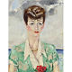 | 410 | Kees van Dongen, 1877- 1968 PORTRAIT DE LA COMTESSE ANATOLE DE BRÉMOND D'ARS  Oil on canvas  Read Condition Report | 250,000 – 350,000 USD  UNSOLD
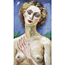 | 411 | Kees van Dongen, 1877- 1968 MADEMOISELLE FESSES DE RAT  Oil on canvas  Read Condition Report | 200,000 – 300,000 USD  SOLD FOR 374.500
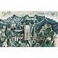 | 412 | Pablo Picasso, 1881-1973 PAYSAGE D'ESTEREL  Oil on cardboard  Read Condition Report | 800,000 – 1,200,000 USD  UNSOLD
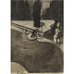 | 413 | Salvador Dalí, 1904-1989 Le Piano Surréaliste  Charcoal heightened with white chalk on paper laid down on board  Read Condition Report | 350,000 – 450,000 USD  UNSOLD
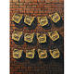 | 414 | Salvador Dalí, 1904-1989 LES YEUX FLEURIS  Oil on canvas  Read Condition Report | 450,000 – 650,000 USD  UNSOLD
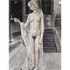 | 415 | Paul Delvaux, 1897-1994 Chrysis  Watercolor, pen and ink and ink wash on paper  Read Condition Report | 250,000 – 350,000 USD  UNSOLD
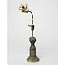 | 416 | Joan Miró, 1893-1983 Figurine (Projet pour un Monument)  Painted iron and partially glazed ceramic  Read Condition Report | 300,000 – 400,000 USD  UNSOLD
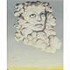 | 417 | Félix Labisse, 1905-1982 L'Evasion Manquée  oil on canvas  Read Condition Report | 20,000 – 30,000 USD  SOLD FOR 18.750
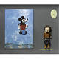 | 418 | Max Ernst, 1891-1976 MICKEY  Oil, oil stick, wood collage and Kachina doll assemblage on panel laid down on board  Read Condition Report | 120,000 – 180,000 USD  UNSOLD
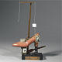 | 419 | Salvador Dalí, 1904-1989  Le Soulier de Gala, Objet Surréaliste à Fonctionnement Symbolique  "Reconstituted object" with a shoe, white marble, photographs, a glass containing wax, a gibbet, a matchbox, hair and a wooden scraper  Read Condition Report | 180,000 – 250,000 USD  UNSOLD
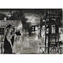 | 420 | Paul Delvaux, 1897-1994 La Mer est Proche (Avant-Projet)  Pen and ink with ink wash on paper  Read Condition Report | 150,000 – 200,000 USD  UNSOLD
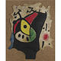 | 421 | Joan Miró, 1893-1983 FEMME DANS LA NUIT  Oil on cowhide attached to burlap  Read Condition Report | 500,000 – 700,000 USD  SOLD FOR 518.500
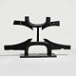 | 422 | Max Ernst, 1891-1976  Êtes-vous-Niniche?  Bronze  Read Condition Report | 60,000 – 80,000 USD  UNSOLD
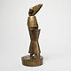 | 423 | Max Ernst, 1891-1976 Habakuk  Bronze  Read Condition Report | 70,000 – 90,000 USD  SOLD FOR 86.500
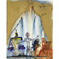 | 424 | Salvador Dalí, 1904-1989 TANCRÈDE  Watercolor, gouache and gold paint on paper  Read Condition Report | 120,000 – 180,000 USD  SOLD FOR 104.500
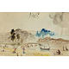 | 425 | Salvador Dalí, 1904-1989 PAYSAGE ANGELIQUE  Watercolor and pen and ink on paper  Read Condition Report | 100,000 – 150,000 USD  SOLD FOR 92.500
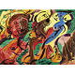 | 426 | André Masson, 1896-1987 Le pÈlerin et les amoureux  Oil on canvas  Read Condition Report | 120,000 – 180,000 USD  UNSOLD
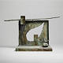 | 427 | Joan Miró, 1893-1983 Femme sur la place d'un cimetière  Bronze  Read Condition Report | 400,000 – 600,000 USD  UNSOLD
 | 428 | After a design by Fernand Léger, 1881-1955  LE TOURNESOL POLYCHROME  Painted and glazed ceramic  Read Condition Report | 250,000 – 350,000 USD  UNSOLD
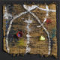 | 429 | Joan Miró, 1893-1983 Sobreteixim 14  Acrylic and buckets on woven wall hanging by Josep Royo  Read Condition Report | 400,000 – 600,000 USD  UNSOLD
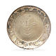 | 430 | Pablo Picasso, 1881-1973 Visage larvé  Silver plate  Read Condition Report | 30,000 – 40,000 USD  UNSOLD
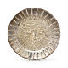 | 431 | Pablo Picasso, 1881-1973 VISAGE TOURMENTÉ  Silver plate  Read Condition Report | 30,000 – 40,000 USD  SOLD FOR 27.500
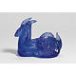 | 432 | After Pablo Picasso, 1881-1973 CHÈVRE  Colored glass  Read Condition Report | 20,000 – 30,000 USD  UNSOLD
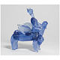 | 433 | After Pablo Picasso, 1881-1973 CENTAUR  Colored glass  Read Condition Report | 40,000 – 60,000 USD  UNSOLD
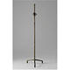 | 434 | Alberto and Diego Giacometti, 1901-1966 and 1902-1985 LAMPADAIRE À L'ÉTOILE  Bronze  Read Condition Report | 100,000 – 150,000 USD  SOLD FOR 98.500
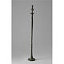 | 435 | Alberto and Diego Giacometti, 1901-1966 and 1902-1985 LAMPADAIRE, MODÈLE FIGURE  Bronze  Read Condition Report | 120,000 – 180,000 USD  SOLD FOR 128.500
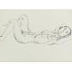 | 436 | Henri Matisse, 1869-1954 Nu allongé  Pen and ink on paper  Read Condition Report | 50,000 – 70,000 USD  UNSOLD
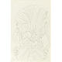 | 437 | Henri Matisse, 1869-1954 Bouquet au fauteuil rocaille, Nice  Black crayon on paper  Read Condition Report | 100,000 – 150,000 USD  SOLD FOR 76.900
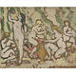 | 438 | Louis Valtat, 1869-1952 Les Baigneuses  Oil on paper laid down on canvas  Read Condition Report | 35,000 – 45,000 USD  SOLD FOR 37.500
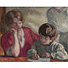 | 439 | Louis Valtat, 1869-1952  La Dictée  Oil on canvas  Read Condition Report | 70,000 – 90,000 USD  UNSOLD
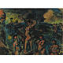 | 440 | Georges Rouault, 1871-1958 AUTOMNE  Oil and gouache on paper laid down on board  Read Condition Report | 120,000 – 180,000 USD  SOLD FOR 86.500

Lot No. | Description | Estimate
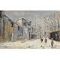 | 441 | Maurice Utrillo, 1883-1955 Neige à Montmartre  Gouache and pen and ink on paper laid down on canvas  Read Condition Report | 40,000 – 60,000 USD  UNSOLD
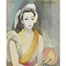 | 442 | Marie Laurencin, 1883-1956  JEUNE BRETONNE  Oil on canvas  Read Condition Report | 70,000 – 90,000 USD  UNSOLD
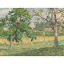 | 443 | Henri Lebasque, 1865-1937 Paysage aux environs de Compiègne  Oil on canvas  Read Condition Report | 60,000 – 80,000 USD  UNSOLD
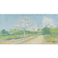 | 444 | Achille Laugé, 1861-1944  AMANDIERS EN FLEUR VERS CAILHAU  Oil on canvas  Read Condition Report | 40,000 – 60,000 USD  UNSOLD
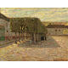 | 445 | Henri le Sidaner, 1862-1939  LES ARBRES TAILLÉS  Oil on panel  Read Condition Report | 50,000 – 70,000 USD  UNSOLD
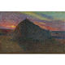 | 446 | Henri Martin, 1860-1943 MEULE DE FOIN  Oil on canvas  Read Condition Report | 100,000 – 150,000 USD  UNSOLD
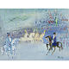 | 447 | Jean Dufy, 1888-1964 LE CIRQUE  Gouache and watercolor on paper  Read Condition Report | 25,000 – 35,000 USD  UNSOLD
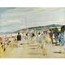 | 448 | Lucien Adrion, 1889-1953 DEAUVILLE, LES PLANCHES  Oil on canvas  Read Condition Report | 60,000 – 80,000 USD  SOLD FOR 104.500
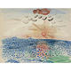 | 449 | Raoul Dufy, 1877-1953 La Mer  Gouache and watercolor on paper  Read Condition Report | 30,000 – 40,000 USD  SOLD FOR 31.250
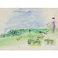 | 450 | Raoul Dufy, 1877-1953 Courses à Deauville  Gouache on paper  Read Condition Report | 80,000 – 120,000 USD  UNSOLD
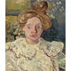 | 451 | Louis Valtat, 1869-1952 Portrait de Madame Valtat  Oil on board  Read Condition Report | 50,000 – 70,000 USD  UNSOLD
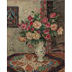 | 452 | Georges d'Espagnat, 1870-1950 Bouquet de fleurs  Oil on canvas  Read Condition Report | 50,000 – 70,000 USD  UNSOLD
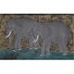 | 453 | Tsuguharu Foujita, 1886-1968 ELEPHANTS  Gouache, watercolor, brush and ink and gold leaf on paper  Read Condition Report | 25,000 – 35,000 USD  SOLD FOR 30.000
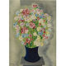 | 454 | Moïse Kisling, 1891-1953  BOUQUET AU VASE BLEU  Oil on canvas  Read Condition Report | 80,000 – 120,000 USD  SOLD FOR 68.500
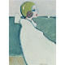 | 455 | Jean-Pierre Cassigneul, b. 1935  LE BONNET DE BAIN  Oil on canvas  Read Condition Report | 70,000 – 90,000 USD  UNSOLD
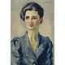 | 456 | Kees van Dongen, 1877- 1968  PORTRAIT DE FEMME À LA ROBE BLEUE  Oil on canvas  Read Condition Report | 100,000 – 150,000 USD  SOLD FOR 110.500
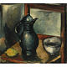 | 457 | Maurice de Vlaminck, 1876-1958 Nature Morte au citron  Oil on canvas  Read Condition Report | 40,000 – 60,000 USD  SOLD FOR 68.500
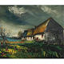 | 458 | Maurice de Vlaminck, 1876-1958 MAISONS ET CHAMPS  Oil on canvas  Read Condition Report | 70,000 – 90,000 USD  SOLD FOR 62.500
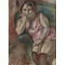 | 459 | Jules Pascin, 1885-1930  LA GROSSE MARCELLE  Oil on board  Read Condition Report | 60,000 – 80,000 USD  UNSOLD
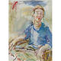 | 460 | Oskar Kokoschka, 1886-1980  STUDY FOR THE PORTRAIT OF RALDA NASH  Oil on canvas  Read Condition Report | 60,000 – 80,000 USD  UNSOLD
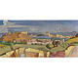 | 461 | André Lhote, 1885-1962 VILLENEUVE ET AVIGNON  Oil on paper laid down on canvas  Read Condition Report | 100,000 – 150,000 USD  SOLD FOR 98.500
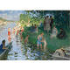 | 462 | Pierre-Eugène Montézin, 1874-1946 LA BAIGNADE  Oil on canvas  Read Condition Report | 100,000 – 150,000 USD  SOLD FOR 98.500
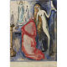 | 463 | Kees van Dongen, 1877- 1968 La prière du Pape  Watercolor and brush and ink on paper  Read Condition Report | 20,000 – 30,000 USD  UNSOLD

